The Official Publication of ALOA—An International Association of Security Professionals

[www.aloa.org](http://www.aloa.org)

November 2001

**GET SMART ON CARS**

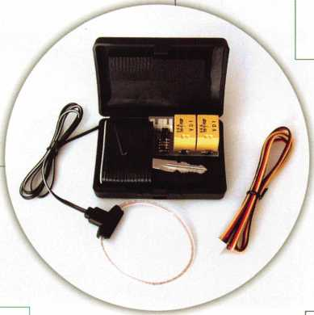

Latest Methods for Ford Fleet Keying

and

Red Howell’s Laundry List of Auto Tips and Tricks

**PLUS**

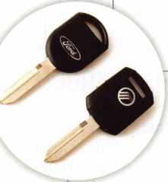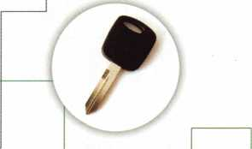

Philosophy for Beginners

Securitron’s Award Winning Mortise UnLatch

AMSEC Gun Safes: You Be the Judge

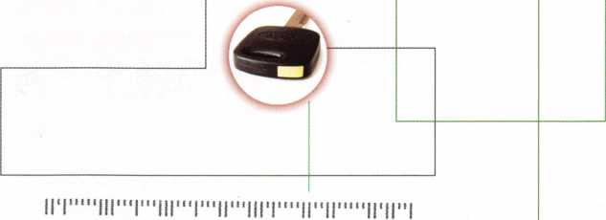

id

0LQ0-Z9ZQZ V3 VINVULV (tdOZtr X08 Od 666Z/IE/ZI 1M3 dUV3 ‘H M33M 2£S £0£ JLI9IG--E##**#**#*#####*

h

The

Terrorist Aftermath: What Can We Do?

Automotive Issue



The



“Your Key to Knowledge”

Volume 1, Number 1

New Disk Arrives!

Absorbs catalogues,  
application  
guides, manuals,  
and spec sheets!

Locksmiths celebrate!

A new CD-ROM from STRATTEC Security Corporation called PartSearch 2001 has arrived on Planet Earth, and lock­smiths everywhere are feeling jubilant. That’s because PartSearch 2001 puts a whole new world of information at their fingertips in just a small fraction of the space it used to take. This disk includes complete product information going back to the 1972 model year, ready for installation on any PC with a minimum of 16 meg of RAM. It’s a complete cross-referenced library in one compact package.

Knowledge is Power!

If knowledge is power, then PartSearch 2001 is destined to be one of the most powerful tools in any locksmith's arsenal. The information can be accessed in a number of ways: by model year, by vehicle make or manufacturer, or by part number. It even references non-STRATTEC part numbers for still more flexibility. And it contains graphics and application guides for thousands of parts, making installation and service a snap.

Time is Money!

The real power of PartSearch 2001 will make itself felt when locksmiths start using it. Instead of leafing through stacks of catalogs, searching for application guides, and checking parts lists; they’ll be finishing jobs quicker, getting more work done, and making more money. In a world where time is money, the value of this little disk is hard to estimate. But the price is easy to handle.



**Get Yours Today!!!**

STRATTEC Leading the Industry Since 1914.

Get your PartSearch 2001  
right away! Don’t delay! Simply  
call your STRATTEC distributor  
and tell them you’ve heard about  
the new disk from STRATTEC

that’s going to make every lock-

smith’s life easier, simpler,

and more profitable. For

just 10 bucks, this is one

CD you’ve just got to

add toyour collection.

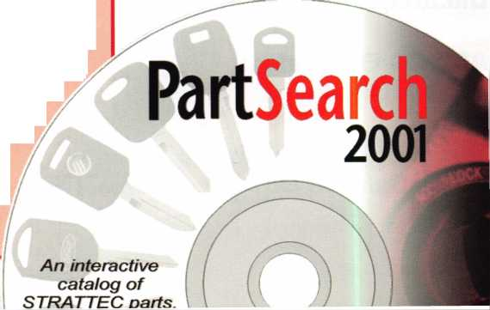

Reflecting



*r\ r* o

rosemont,illinois

**Rosemont**

**Convention**

**Center**

**Regency**

**O'Hare**

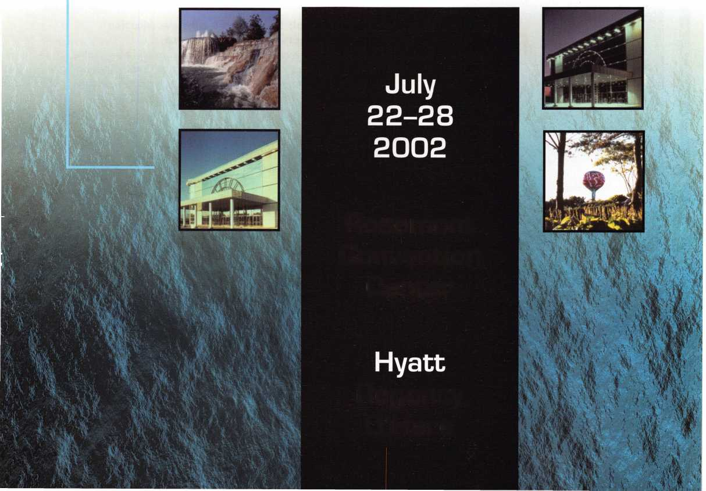

features

|  |  |
| --- | --- |
| \ departments | | |
| President's Journey | 3 |
| Upcoming Events | 5 |
| Core | 9 |
| Applicants | 7 |
| Legislative Update | 37 |
| Classifieds | 39 |
| Associate Member Listing | 41 |
| Back Page | 43 |
| L |  |



Cover: Double Feature Automotive Issue

Part 1:

Transponder Security—Ford Fleet. By Tom Seroogy

How do you accomplish fleet keying with a transponder- equipped Ford vehicle? A Lockamsters Auto Specialist answers that and more in this cutting edge breakdown.

Part 2:

Red's Laundry List of Tips and Tricks by Red Howell, crl

Red Howell, CRL, takes you through a hodge-podge of his favorite auto opening tips and tricks. A great overview for young and old.

**SI** Basic Locksmithing:

Philosophy for Beginners By Merritt Perkins, RL

This overview takes you through a brief history of our profession, and includes a number of basic locksmithing scenarios in which the pursuit of knowledge always prevails. (The moral of this story won't escape you.)

**25**

Access Control: Securitron/s all-new Mortise UnLatch Universal Electronic Strike

Take a look at the features and servicing requirements of the Mortise UnLatch, which was recently awarded the Access Control Product Achievement Award at the 2001 ISC East New product Showcase in New York City.

**29**

Forensic Locksmithing:

Methods for Growth By Don Sh iles, RL

Most locksmiths and safe technicians have used forensic methods to assist law enforcement officials to catch criminals at one time or another. This in-depth look at certain forensic scenarios will help you pitch yourself as an important link in the security chain.

**33**

Safes: AMSEC Gun Safe—

YOU Be The Judge ByGregPerry,CML,CPS

Finding the perfect gun safe is never easy. You have to mix and match features and service requirements with the customer's ever- changing needs. AMSEC's gun safes are one option. Do you know if it's the right one for your next customer?

Visit

our we

b s i t e at

WWW

a I o a

o r

9

Keynotes

executive



Editor

Jim DeSimone

Additional contact information for the ALOA Board and most Keynotes authors is available through "Locksmith Search'" on the ALOA Web site- [www.aloa.org](http://www.aloa.org) or by contacting the ALOA office at 3003 Live Oak Street; Dallas, TX 75204; (800)532-2562; FAX (214)827-1810; e-mail [aloa@aloa.org](mailto:aloa@aloa.org).

Operations/Membership Manager

[editor@aloa.org](mailto:editor@aloa.org) Mary May [mary@aloa.org](mailto:mary@aloa.org)

Technical Editor

David Lowell, CML, CMST [david@aloa.org](mailto:david@aloa.org)

Director of Information Technology

Randy McChristian [randy@aloa.org](mailto:randy@aloa.org)

Editorial Advisor

John D. Cannon, CML [jdcannon@worldnet.att.net](mailto:jdcannon@worldnet.att.net)

Art Director

Betty Henderson [betty@aloa.org](mailto:betty@aloa.org)

Advertising Sales

Susan Haverkamp e-mail: [adsales@aloa.org](mailto:adsales@aloa.org)

121 Davis Street Nacogdoches, Texas 75961 Phone: (936) 569-7172 VoiceMail: (208) 248-8893

Executive Director

Charles W. Gibson, Jr., CAE [charlie@aloa.org](mailto:charlie@aloa.org)

Convention & Meetings Manager

Kelly Carr, CMP [kelly@aloa.org](mailto:kelly@aloa.org)

PRP/Education Manager

David Lowell, CML, CMST [david@aloa.org](mailto:david@aloa.org)

Government Affairs Manager/

Chapters & Regional Associations Liaison

Tim McMullen [tim@aloa.org](mailto:tim@aloa.org)

Comptroller Kathy J. Romo

Network Specialist Greg Jackson

Membership Coordinator Shelly Jett

Convention & Meetings Assistant

Karen Lyons [karen@aloa.org](mailto:karen@aloa.org)

PRP/Education Coordinator Ashley Manson

Accounting Coordinator Kathy Stokes

Mail Room Coordinator Humberto Cerda

Receptionist Alin Valdez

Contributors

Jerome Andrews, CML Paul Chandler, CRL Claire Cohen, CML Brian Costley, CML, CMST Ray D'Adamo, CML

Sal Dulcamaro, CML Billy Edwards, CML Dan Graffeo, CRL,CMST AJ. Hoffman, CML Jeff Nunberg, CML, CMST

Mike Oehlert, CPL, CPS Randy Simpson, CML Robert Stafford, CML Dave Thielen, CML Greg Perry, CML,CPS

Tom Seroogy Charles Stephenson, CPS Dennis Watanabe, CML, CMST

Mission Statement: The Associated Locksmiths of America, Inc. is dedicated to enhancing the professionalism, education and ethics among lock­smiths and those in related sectors of the physical security industry. With approximately 10,000 members in the United States, Canada and the free- world, ALOA is poised to help members obtain the knowledge, the strength, and the confidence to perform their role in the physical security field with pride and dignity. But it is only through active involvement and participation that ALOA can fully achieve its potential—and can help members to achieve theirs.

Policies: Keynotes® is the official publication of the Associated Locksmiths of America, Inc. (ALOA). Keynotes® acts as a moderator without approving, disapproving, or guaranteeing the validity or accuracy of any data, claim, or opinion appearing under a byline or obtained or quoted from an acknowl­edged source. The opinions expressed by the authors do not necessarily reflect the official views of ALOA. Also, appearance of advertisements and new products or service information does not constitute an endorsement of products or services featured by the Association. The Association does not accept responsibility for the inaccuracy of any data, claim, or opinion appearing in this publication, due to typographical errors on the part of the authors, Association staff or its agents.

Editor's Note: This publication is designed to provide accurate and authoritative information in regard to the subject matter covered. It is provided and disseminated with the understanding that the publisher is not engaged in rendering legal or other professional services. If legal advice and other expert assistance is required, the services of a competent professional should be sought.

Authors' Payment: Payment for eligible submissions to Keynotes will be based on the following criteria: topic, time spent and past contributions. Authors who regularly submit to Keynotes® are generally paid a higher rate. The latter is especially true of authors who write to fit specific editorial needs and submit said copy by Keynotes® deadlines. As a general guideline: Average payment for a 750 word, business or 'light' technical article would be $200. Payment for a 1500 word article involving significantly higher time and research efforts would be $400.

Payment will not be offered for articles submitted by ALOA employees or members of the ALOA Board of Directors (unless material is of a technical nature), nor for articles submitted by a company that promote that company's products or services. ALOA reserves the right not to pay for articles sub­mitted by an individual(s) that promote a particular company's products or services.

Disclaimer: The Associated Locksmiths of America, Inc., (ALOA), reserves the right to refuse any article for any reason. Additionally, ALOA reserves the right to edit, amend or modify any article submitted for publication in order to preserve technical accuracy, clarity, fairness or grammatical cor­rectness. ALOA will make the best efforts to notify the author of any changes. The extent of ALOA's liability for any article or information contained therein will be a notice of correction or retraction in the next possible issue.

Keynotes® (ISSN 0277 0792) is published monthly except for the combined June/July issue by The Associated Locksmiths of America, Inc., 3003 Live Oak St., Dallas, TX 75204-6186. Telephone: (214) 827-1701; FAX (214) 827-1810; e-mail [aloa@aloa.org](mailto:aloa@aloa.org). Subscription rates for members—$15.00 per year. Second class postage paid at Dallas, Texas. POSTMASTER: Send address changes to: Keynotes, 3003 Live Oak St., Dallas, TX 75204-61 86. © Copyright 1999, All rights reserved. No part of the contents may be reproduced or reprinted in any form without prior written permission of the pub­lisher.

President

Randy Simpson, CML (713) 780-7026 ■7 [president@aloa.org](mailto:president@aloa.org)

Secretary

: John D. Cannon, CML;

(703) 960-6413

[jdcannon@worldnet.att](mailto:jdcannon@worldnet.att). net

Directors, Northeast

John C. Magee, III

(856) 845-3434

Peter Sarailian, CRL  
(201) 947-6291  
[psarailian@yahoo.com](mailto:psarailian@yahoo.com)

William L. Young, CML

(610) 647-5042

Directors, Southeast

Vincent Formon, CML, CPS

(901) 324-2910

Donald E. Rule, CML  
(601) 324-2658  
rulecml@eb:com. net

Directors, North Central

Mark E. Blum, CML, CPS  
(517) 482-5809  
[mblum@arq.net](mailto:mblum@arq.net)

John Soderland, CML, CMST  
(414) 327-5625  
ncdi rector@aloa .org

Director, South Central

Randy L. Simpson, CML

1. 780-7026

Directors, Southwest

Gordon R. Racine, CML  
(719) 384-4707  
[swdirector@aloa.org](mailto:swdirector@aloa.org)

Julie McCiuney, CRL

1. 636-5652

[swdirector@aloa.org](mailto:swdirector@aloa.org)

Director, Northwest

Scott L. Henke, CRL, CPS  
(907) 248-3785  
[action@alaska.net](mailto:action@alaska.net)

Director, Associate Members

David F. Matthies  
(727) 541-5536  
[dmatthies@southernlock.com](mailto:dmatthies@southernlock.com)

Trustees

John J. Greenan, CML, CPS

(773) 486.2030

Dallas Brooks

(334) 826-8990

David M. Lowell, CML, CMST

(800) 532-2562

Edwin Toepfer, RL

(416) 225-5589

Past Presidents

1999-2001 John Greenan, CML, CPS 1997-1999 Dallas C. Brooks 1995-1997 David Lowell, CML, CMST 1993-1995 BreckCamp, CML 1991-1993 Henry Printz, CML 1989-1991 Evelyn Wersonick, CML, CPS 1987-1989 Leonard Passarello, CPL 1985-1987 Joe Jackman, CML 1983-1985 Stanley Haney, CPL 1981-1983 Louis LaGreco, CPL 1979-1981 John Kerr, RL j 1977-1979 Clifford Cox, CML 1974-1977 Charles Hetherington 1972-1974 Gene Laughridge 197G1972 William Dutcher, RL 1968-1970 Constant Maffey, RL 1966-1968 Harold Edeistein, RL 1964-1966 William Meacham 1962-1964 Robert Rackliffe, CPL 196a1962 Edwin Toepfer, RL 1956-1960 Ernest johannesen

Keynotes



|  |  |  |  |
| --- | --- | --- | --- |
| p r e s i < | d e | n 1 | 1 s |
| j o U 1 | • n | e y | r |

Hello Members,

It does not seem that today is a day to smile. Current events have diminished the joy of everyday life. Just three Days before the terrorist attacks I was enjoying a wonderful week­end in Philadelphia with all of the members of the GPLA. It was a beautiful weekend and a wonderful show. The finale of the show was a banquet and Awards ceremony for past instructors of GPLA. Gathered were about 20 of the most proficient teachers of our indus­try. They embody the strength of our industry with their ability to empower our industry's future.

Since Tuesday the 1 1 th of September my thoughts and prayers have been for the people who have lost loved ones due to these attacks. Our board has concerns that some of our members may have been directly affected. So far we have not heard of any. If you know of anyone directly affected by these terrorist attacks, please let us know.

I dropped all of the money I had in my pocket into the boot of a fireman at the last red light when I stopped. I feel grief for them. Their association lost hundreds of members' lives.

I am impressed with the commitment they have for their associates. Hug someone today and let him or her know that you love them. This month, we have a nice article from Jim Hancock, CRL, about what locksmiths can do in these times of great strife. And I will leave you this month with some comments we have received from a board member, Don Rule, CML:

"We will not soon forget September 11, 2001. Please pray with me in the weeks and months ahead as the young men and women of our armed forces are placed in harm's way."

Randy Simpson, CML

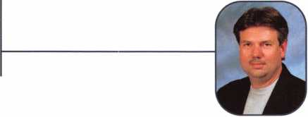

3

Keynotes



HZE7

***Visit our Website on****[www.stamcctv.com](http://www.stamcctv.com)*

**THE COMPLETE**

**CCTV PROGRAM ON CD-R(**

**FOR STAFF TRAINING AND**

**PRODUCTIVITY ENHANCEMENT**

STAM **Insight** has been  
developed to enhance CCTV  
skills and productivity with  
many different uses.

1**10** Productivity



System Drawing Estimation CCTV Training CCTV Reference Sales/Demo System Design Staff Evaluation

J4 hours

CCTV Content

It ftptw*

CCTV Calculators

Demonstration Tool

Estimation

Drawing

Internet Enabled

**INFOMATE WORKMATE ULTIMATE**

**Sold in Over 50 Countries**



Name:

Job Title:

Organization:.



3003 Live Oak Street  
Dallas,Texas 75204

Address:

Zip/Postcode.

..e-mail.

..Fax:

COPYRIGHT © 1996 Security Training and Marketing Pty Ltd. All rights reserved ACN 057 006 541

Country

Tel: ( )

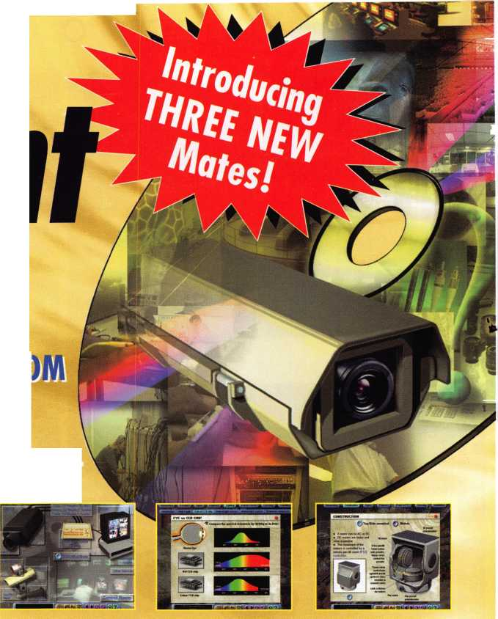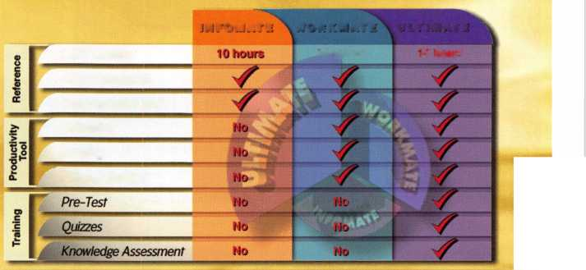

**APRIL ■ MARCH ■ FERUARY ■ JANUARY ■ DECEMBER ■ NOVEMBER**

upcoming

|  |  |  |  |
| --- | --- | --- | --- |
| 9 | 7-11 | 17 | 17-18 |
| PRP • Dallas, TX • Ashley Manson | Yankee Security Convention | PRP • Grand Canyon Chapter | Oklahoma Locksmith Association |
| (800) 532-ALOA (2562) | 12 ACE Classses • Sturbridge, MA | of ALOA • John Ilk, CML | Cylinder Servicing, Lockset Functions & |
| [education@aloa.org](mailto:education@aloa.org) j | Stephen McKinney • (617) 789-3274 | (602)574-5277 | Finishes and Lockset Servicing |
|  |  |  | Charles Hudecek • (580)352-3232 |

14

PRP • Dallas, TX • Ashley Manson

(800) 532-ALOA (2562)  
[education@aloa.org](mailto:education@aloa.org)



19-20

ACE Classes • Foreign Auto Butte, MT • Montana Chapter of ALOA • Todd Rasmussen, CRL 406-883-2950 • 406-883-2950



21-26

ACE Classes • Basic Locksmithing Appleton, Wl • Fox Valley Technical Jerry Antoon • 920-735-2406 920-735-2414 • [antoon@foxval- leytech.com](mailto:antoon@foxval-leytech.com) [www.foxvalleytech.com](http://www.foxvalleytech.com)

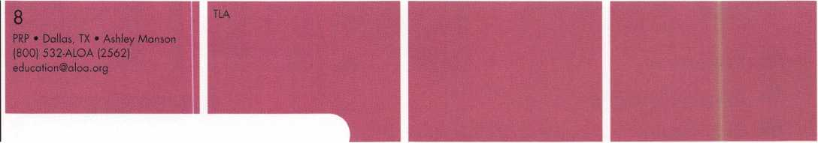

8

PRP • Dallas, TX • Ashley Manson (800) 532-ALOA (2562) education@aloa .org

18-23

ACE Classes * Basic Locksmithing Appleton, Wl • Fox Valley Technical Jerry Antoon • 920-735-2406 920-735-2414 • [antoon@foxval- leytech.com](mailto:antoon@foxval-leytech.com) • [www.foxvalleytech.com](http://www.foxvalleytech.com)



8-13

SAFETECH 2002 • Reno NV Contact ALOA • (800)532-2562 or (214)827-SAFE (7233) [www.safta.org](http://www.safta.org) • [dialcenter@aloa.org](mailto:dialcenter@aloa.org)

20 ACE Classes and PRP • Somerset, NJ Dan McGlynn, CML • 973-267- 8884 973-538-1588 • [dfmcml@home.com](mailto:dfmcml@home.com) [www.mlanj.com](http://www.mlanj.com)

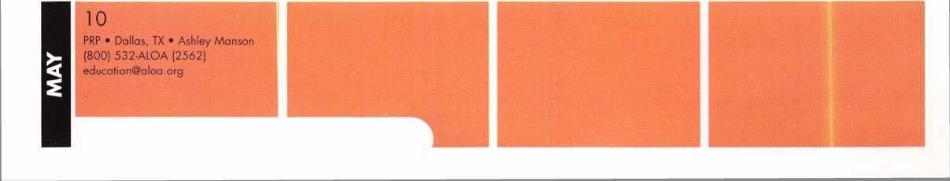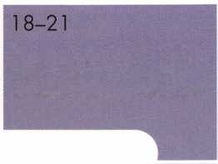

**DECEMBER ■ NOVEMBER ■ OCTOBER ■ SEPTEMBER ■ AUGUST ■ July ■ JUNE**

events

14

PRP • Dallas, TX • Ashley Manson (800) 532-ALOA (2562)

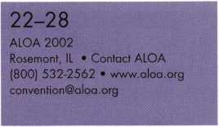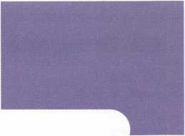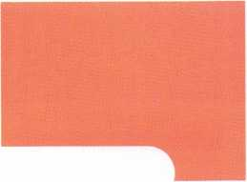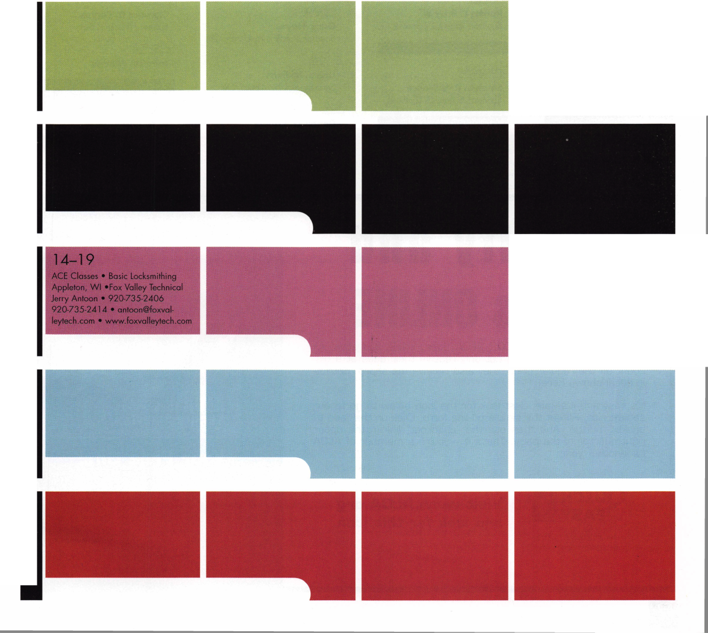

Alabama

Illinois

Pelham

Danny C. Booth

Sponsor: Dallas C. Brooks

California

San Diego

John M. Williams

Sponsor: Gregory A. Parks, CRL

San Francisco

Justin C. Jacobs Van Nuys David V. Fuentes

District of Columbia

Washington

Edward J. Holt



Lawrenceville

Isaak H. Teklu

Sponsor: John C. Elliott; Jr, CML, CPS

Belleville

Sharon M. Shafiq

Louisiana

Denham Springs

Clay A. Harris

Sponsor: Allan C. Halverson

Massachusetts

Chicopee

Robert L. Bray III

Sponsor: Robert D. Lamothe, CRL

Maine

Springvale

Stephen R. LaFrance

Sponsor: Richard G. Lamb, RL

Mississii

Poplarville

Darryl G. Smith

Sponsor: Richard Brady Sr



North Cape May

David A. Sykes

Sponsor: James M. Watt, CML, CPS

New York

West Seneca

James K. Beck

Sponsor: John S. Blando

Texas

Arlington

Gary Hayes

Sponsor: Randy L. Hutchison, CRL El Paso

Laura Milliorn

Sponsor: Rick H. Milliorn, CRL

Fate

Dennis G. Cauble

Sponsor:

Clifford D. Lipscomb, CML, CPS

Plano

Mike D. Dunkerley

Sponsor: Gorman Brewer, CML



Arlington

Terry I. Gadsden

Sponsor: Michael B. Groves

Newport News

Leon Jeffries

Norfolk

Clarence D. Bonner

Sponsor: Brooke P Berry

Quantico

John W. Weaver

Canada

Toronto

W H. Parr

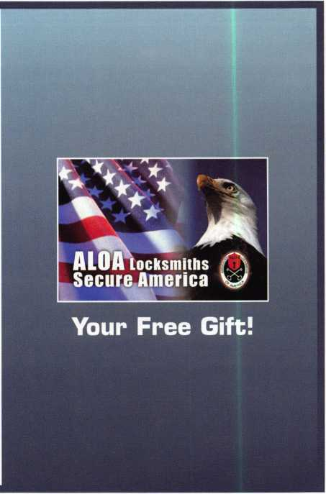

Security and  
Savings ONLINE

Now you can pay your 2002 ALOA dues on-line and save! All  
members renewing on-line not only receive their dues at a dis-  
count off the regular price, they also receive the sharp, patriot-  
ic decal shown here.

It's easy and it's safe. Just look for the icon below to go to our  
secure site. Fill out the simple on-line form. Click on the "add to  
basket" button. And then use the "checkout" link in the upper  
right quarter of the page. That's it - you're a member of ALOA  
for another year.

Visit [www.ALOA.org](http://www.ALOA.org)  
and look for this icon

**Now PAY Your Dues**

**ONLINE AND SAVE!**

Keynotes

Leonard J. Passarello CPL 13

Frank D. Hartung CML 13

Rolando Bouza 13

Paul M. Souber 13

Donald H. Shiles RL 13

Richard C. Sievers 13

Joe J. Lee CRL 13

Ernest W. Wright 1 2

Raymond C. Lusk CML 1 2

John F. Engel CRL 1 2

Eric F. Veal 12

Thomas J. Demont CML, AHC 1 1 Basil W. Shannon CPL 11

Calvin G. Harris CML 1 1

Herbert C. Dusenberry CML, CPS1 1 Timothy K. Chow 1 1

Dale L. Knowles CPL 11

Alvin N. Minor 1 0

Gene Eldridge CPL 10

Ronald P. Riggins CML 1 0

Lester S. Brodsky 10

Larry L. Votaw CML 10

Thomas R. Smith CPL 10

William T. Straub CML 10

Richard T. Johnson CPL 1 0

Dale V. Crosby CPL 10

James V. Hawley CRL 10

Eugene R. Altobella Jr 10

James Bright 1 0

*ALOA Board of Directors not eligible for membership in the President's Club

How can I join the  
President's Club?

You can earn a membership in this  
prestigious club by recruiting just  
10 new members for ALOA.

*Any ALOA member may participate.

What do I get?

When you recruit 10 members, you  
receive a handsome blue blazer  
with a President's Club crest. For  
each additional five members you  
recruit, you receive a lapel pin with  
gold-filled numbers, indicating, your  
recruiting successes.

You also get the satisifaction of  
knowing that you are helping your  
association, helping your industry  
grow, and you are helping fellow  
locksmiths achieve success.

How do I get started?

Contact the ALOA office for a sup-  
ply of applications (800) 532-ALOA  
or FAX (214) 827-1810. One  
President's Club credit is awarded  
for each new applicant. Credit is  
awarded only after the membership  
application is pproved. However,  
the credit will apply for the period  
in which the application is  
received. Failure to identify yourself  
as the sponsor on the application  
form at the time it is submitted  
to ALOA for processing will  
forfeit any credit.

Name Members

Recruited

Kwok-kei Leung 204

Toshihiro Asano 1 1 3

Henry W. Raymond 100

Yuriko Yanai 69

Stewart J. Levine CML 66

Mary S. Ohmit CPL 66

Charles C. Robertson CML 65

Jack Hobin CPL 51

William B. Neff CML 48

Salvatore J. Dulcamaro CML 40

Myeong-Rae Cho 38

Dana L. Barnum CML 35

Barry K. Leas CRL 35

C Allan Halverson 34

Danny W. Rudd CPL 31

Larry A. Warnick CML 31

Jeanne G. Lodge CML 30

Breck H. Camp CML 28

William Lee 28

Lawrence F. Smith Jr, CML 27

James M. Watt CML, CPS 27

Jim Williams CRL 27

Anthony J. Ramunno CML, CPS 26 Marian M. Swann CRL 26

Jeffrey S. Nunberg CML, CMS 26

J Thomas Hood CML 26

John C. Elliott Jr, CML, CPS 25

James H. Glazier Sr, CML 25

Robert F. Carroll CPL 25

Robert H. Stafford CML 25

Robert D. DeWeese CML 24

Jerome L. Cohen CML 23

Peter K. Gauthier CPL, CPS 23

Elvis D. Hammerschmidt CPL 23

Man-Soo Seo 23

Diana R. Barnum CRL 22

Michael B. Groves 22

James J. Cawby CML, CPS 21

Philip A. Rovenolt CPL 21

Eugene R. Altobella Sr 21

John L. Shandy CML 19

John S. Dorsey CML 19

D Michael Lee Sr, CPL 19

Robert W. Duman Sr, CML 19

James E. Fowler Sr, CML 1 8

David C. Harris CML 1 8

Walter W. Lascar RL 17

Peter R. Hall 17

Thomas G. Vandersteen CML, CPS 17

William P. Grant CRL 17

Keizo Takahashi CRL 17

Evelyn V. Wersonick CML, CPS 16 Joseph P. Ferrero CML 16

Gary F. Teams CPL 16

Kenneth E. Kim CRL 16

Michael E. Jordan Jr, CML 16

Brian J. Reetz 16

Robert C. Rodocker CRL 15

William J. McElheney CML 15

Joseph W. Whitaker CPL 15

Jon B. Griswold CML 15

Michael D. Robinson CRL 15

Russell P. Fuller CRL 15

Daniel L. Landry Jr. 1 5

James L. Hancock CRL 15

James E. Gruber CRL 14

James T. Brickler CRL 14

Joseph C. Fuller CML, CMST 13

Keynotes

8

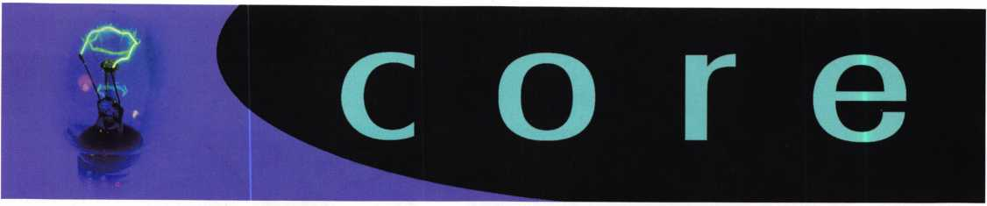

ALOA Heroism Stops  
Plane Disaster

Long-time ALOA member and ACE Instructor  
Bill Neff, CML, was on a routine flight back from  
his vacation in Australia and was connecting  
through Chicago. Always a first-class passenger,  
he was in seat 3A, which of course is at the  
front of the plane. All

of a sudden, he heard  
the sound of running  
and looked up to see  
someone charging for  
the cockpit saying,

"We're going to crash  
into the Sears Tower!"

(The Sears Tower is, of  
course, the tallest  
building in Chicago.)

Immediately following  
the first man was the  
sound of three or four  
others saying, "Stop  
him - he's headed for  
the cockpit!" The first  
man kicked open the  
cockpit door and star-  
tled the captain and  
copilot so much that it

caused the plane to veer. Bill jumped up and  
with the three other passengers grabbed the  
hijacker and fell on

top of him to restrain him. The plane then land-  
ed and the hijacker was taken off the plane.

Bill was interviewed by CNN and the photos  
of the disturbed man being apprehended by  
the authorities were picked up by the  
Associated Press.

When we say "Locksmiths Secure America,"  
we mean it. Thanks Bill, for doing our  
profession proud.

Small Airports;

Big Concerns

Baltimore-Curb-side baggage check and metal  
detector dashes at major airports have given  
way to individual bag searches and slower  
trips around the nation.

"To say that airline security tightened around  
the country within the last two weeks would be  
an understatement," comments Gunther Than,  
President and CEO of a Baltimore-based digital  
security manufacturer called View Systems, Inc.  
"On my most recent flight, attendants even  
examined my shaver."

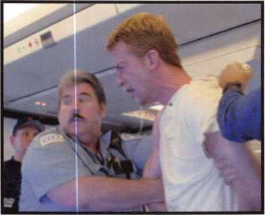

Authorities apprehend this visibly disturbed man, who tried to  
attack a Chicago-bound flight crew but was manhandled and sub-  
dued by long-time ALOA member, Bill Neff, CML.

(Photo by Bill Neff, CML)

Attorney General John Ashcroft proposed the  
idea of using expanded electronic surveillance  
and added search authority by law enforcement  
officials to profile potential terrorists. Than hopes  
officials also consider the same levels of security  
for smaller and noncommercial venues.

Robert Collins, President of the Aviation Crime  
Prevention Institute (ACPI) says, "I doubt terrorists  
would even attempt

major establishments in  
the near future like  
Dulles Airport for exam-  
ple, because of the  
newly increased securi-  
ty measures. They  
would probably target  
general aviation planes,  
air charter or small  
regional airlines, with  
the hope of slipping  
through the cracks so to  
speak."

The ACPI helps educate  
general aviation pilots,  
and the industry on  
security awareness,  
theft prevention  
and other types of  
airspace crime.

"We are technologically-rich society capable of  
securing our airports from terrorists, but it's cru-  
cial that we take nothing for granted and act  
immediately." continues Collins.

Than has seen a dramatic rise in information  
requests for his surveillance products lately.

He attributes it to the impact of digital surveil-  
lance. View System's security systems record  
images digitally like a VCR, but offer a major  
improvement over analog technology. View  
System's users can access their systems wireless-  
ly via modem from anywhere in the world in  
real-time play.

View System has also developed a facial recog-  
nition tool. It can match a facial image digitally  
to police and FBI databases of criminals and sus-  
pected terrorists. View Systems also plans to  
bring a high-speed mobile system to market. It is  
currently in beta test with law enforcement agen-  
cies. The technology, PlateViewTM, can read  
license plates and transmit the information to  
headquarters for inquiry against wanted, stolen  
and tracked vehicles.

"I'm grateful to contribute to the safety and  
peace of mind of America," says Than.

"Securing airports is really just the beginning.

As Congress passes legislation to increases law enforcement capabilities, we hope to help by providing the tools they'll need."

Obituary

David Franchuk  
built his business  
on integrity and  
the the pride that  
comes from a job  
well done.

The ALOA family has lost one it's finest locksmiths, David Franchuk, CML.

David and his wife, Kathy, started Guardian Lock Co. in Bismarck, ND in the late 1980s.

He strived to build his business on integrity and the pride that comes with work well done, a trait that is becoming hard to find.

David had two dreams in life: one was to do only safe work and the other was to move to Tennessee. He was able to make his dreams come true in 1999 when he sold Guardian Lock Co., and moved to Tennessee to start Southern Safe Opening Service.

Some of David's heroes included Dave McOmie, Skip Eckert and Mark Bates. He was also proud to have some of his own safe article published.

Employee and friend, Bill Ortmann remembers the closeness they shared working together and appreciates everything he learned from David.

The greatest loves in David's life were God, his wife, Kathy, and the challenge of a good safe.

With tears in our eyes and broken hearts, we say farewell. David's memory will always be with us.



New Certifications

CMLs

Greg Brandt

CPLs

Curtis Jones Timothy Horton

CRLs

Paul Carchia Robert Deck Kevin Savoy Eljie Lejeune

Overland Park, KS

Lexington, KY  
Manassas, VA

Arlington, VA  
Burlington, KY  
Levithown, PA  
Bakersfield, CA

Keynotes

**Renew or Apply for Membership ONLINE at [www.aloa.org](http://www.aloa.org)**

LOCKSMITHS

**During times of crisis, unity is key. Right now, when you join ALOA  
(or renew your membership), you will receive, free of charge,  
this patriotic decal for your shop or van, which serves as a  
special reminder to you and your customers that it takes  
a spirited effort to strengthen the ties that bind us.**

HLUH locksmiths

Secure America

**Decal dimensions 8y2" x S'A"**

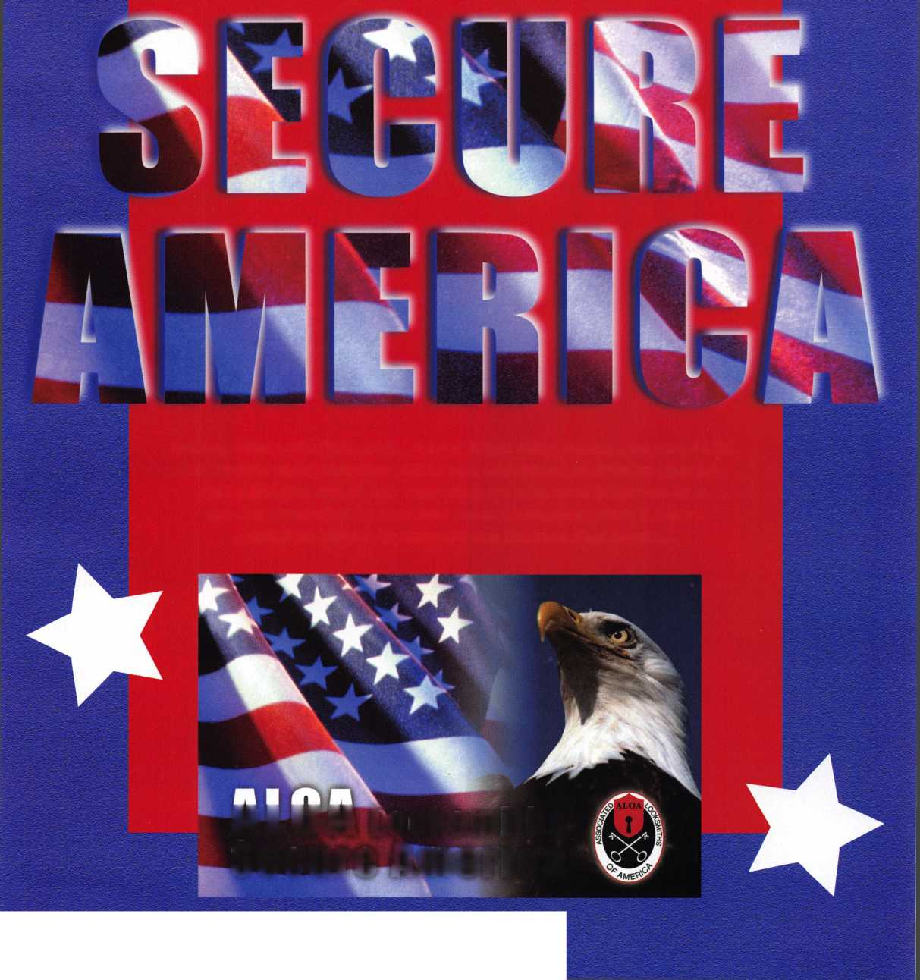

What

Can

We

Do?

Jim Hancock, CRL

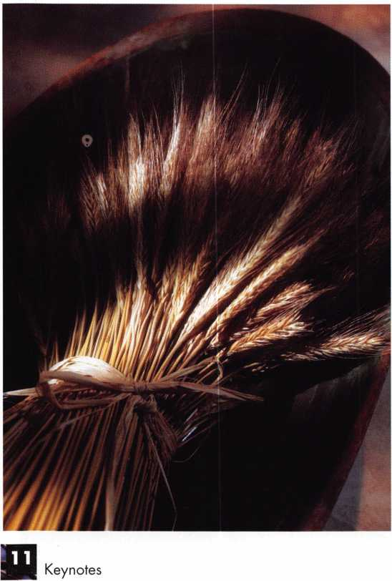

September 11, 2001.

This is a date that will stay with us

for all of our lives. It is a day that we will all  
remember exactly where we were when we heard  
the first reports of what sounded like a tragic accident  
between an airplane and a high rise building. It is a  
day that those of us with access to a television at that  
moment will certainly remember as we got visual  
confirmation that it was no accident. This was not our  
first experience with terrorism; we are already heal-  
ing from the Oklahoma City attack and the bombing  
in the garage of the WTC. But for those of us not liv-  
ing in or around Oklahoma City or NYC at the time  
of those tragedies, the reports were somewhat like  
watching an old newsreel report from the World War

II or Vietnam era;  
very tragic but some-  
what removed from  
our little worlds  
because we saw only  
aftermath. On  
September 11, we  
watched in horror as  
many innocent peo-  
ple lost their lives as  
an airplane careened  
into a building full of  
people just trying to  
earn a living and sup-  
port their families.

This image has been burned into our memories forev-  
er. Yes, September 11, 2001 will be one of those days  
that we will all remember exactly where we were and  
what we were doing. It will be added to the list along  
with November 22, 1963 when we first heard the  
reports of a shooting in Dallas and that early January  
1986 morning when perhaps a customer asked us if  
we heard about the space shuttle Challenger explod-  
ing. These days define us as a nation by their tragic  
nature but perhaps more so by how we as a nation  
deal with the tragedy and its aftermath. It is the after-  
math that helps define some of our nations industry  
and the ability to adapt to an ever-changing world.

It is this aftermath that is surely going to help define  
our profession. The need for higher levels of security  
and access control has never been greater. As the  
nation in general turns toward our government to pro-  
vide a heightened level of military presence and  
diplomatic pressure to assure that these terrorist acts

On September 11, we watched in horror as many innocent people lost their lives as an airplane careened into a building full of peo­ple just trying to earn a living and support their families.



The question is not what can we do but rather  
what CAN’T we do.

Photos courtesy Joseph Loglisci

do not recur on American soil or anywhere else in the world, we, the security  
professionals, will be called upon to provide greater physical security measures.

We, as a profession, must now be more well rounded in our abilities to provide  
the types of access controls and security products that are going to be needed to  
help our nation feel more secure at work, at home and as they travel. This is

going to require us to put aside our competitive natures and be willing to teach and learn from others in our business. It  
is going to require sharing information and most importantly, it’s going to require us to be forthcoming with ourselves  
and realize when a job is above our expertise and be willing to turn that job over to a “competitor” for the good of the  
customer. Its going to require, for some of us, developing a greater interest in our associations and the classes that they  
offer. For it is these classes that will enable us to be more well rounded and provide that greater level of security and  
peace of mind that this nation needs. It’s going to require state and local associations to be more pro-active in setting up  
classes both at their conventions and during the interim between conventions. And it’s going to require manufacturers to  
be more available to set up training on their products and be willing to travel with that training and certify others to train  
in their products.



What can we do ? We as independent businessmen and women can realize that our customers need us more than ever and are going to rely on our expertise and knowledge of all aspects of physical security to provide them with the best products for their particular needs as well as the best workmanship possible to assure a secure environment.

Mechanical lock mechanisms have been around in some form or another since the beginning of recorded time and prob­ably even before. Mechanical locks will always be around, however, beginning well before September 11th and of course even more so now, the focus and the need is on electronic access and electronic surveillance such as CCTV.

These two aspects of our changing industry strike fear and dread in the hearts of some. No, its not as simplistic as rekey­ing that Kwikset door knob or adding a deadbolt to a door for security purposes. But let’s face it, the times they are a changin’. We no longer live in a world where simply installing a key control product like Medeco is going to be suffi­cient at our airports, government buildings, military installations and the like. We now are going to have to learn elec­tronic access and be able to sell, service and support these products. We are going to have to stay on the cutting edge of this technology by becoming more involved in all of our national resources such as ASIS, DHI, SAVTA and ALOA. And finally, from a purely commercial standpoint, we’re going to have to realize that this profession cannot be driven by the almighty dollar but should be driven by our desire to help our fellow man and woman regain that feeling of safety and security we once had.

From a more personal standpoint, what can we do ? Perhaps we can turn to our associations, both local and national, to honor the many law enforcement agencies and firefighters that have given of themselves so selflessly in our nations greatest time of need since Pearl Harbor. Perhaps our distributors can band together to give donations and set up blood drives among their customers.

Perhaps one of the things we can and should do is return to the roots in which our nation was founded. It seems that in times of crisis we renew our patriotism and our ability to be more tolerant of our fellow man.

We tend to return to the church for answers and prayer. What I think we can do is to carry this attitude year round for the rest of our lives. We truly are one nation, under God, indivisible. Our forefathers saw this vision and expressed it in the documents of our nations birth.

The question is not what can we do but rather what CAN’T we do. God bless us all and God bless the United States of America. Qj

Keynotes

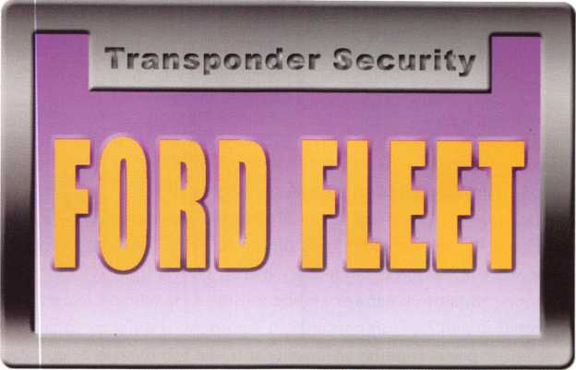

S

ince the release of Ford’s PATS system, lock-  
smiths are constantly challenged with service  
issues involved with key duplication and genera-

tion. One key issue centers on the locksmith’s ability  
to fleet key Ford’s equipped with transponder security.

When first introduced in 1996, the Ford PATS system (dubbed PATS I) allowed for a total of only 16 keys to be programmed into the vehicle. Changes to the system in 1998 (PATS II) included lowering the number of acceptable keys to eight. Needless to say, regardless of which system is being worked on, the maximum key limitations severely affect companies and organizations that need large numbers of keys for multiple vehicles.

new twist to the fleet keying puzzle. As each transpon­der in a transponder key contains a different value, cre­ating large numbers of identical keys is, for all practical purposes, impossible. This is especially true of Ford where there are over 4 trillion different transponder code possibilities and key cloning is not possible.

Three Methods for Fleet Keying

So, then, how does one accomplish fleet keying with a transponder equipped Ford vehicle? Currently, three options are available; the use of bypass systems, Fords Fleet key, and Ford’s Unlimited Key Mode.

Factors Affecting Fleet Keying

From the largest of utilities to the smallest of police departments, three different fleet key scenarios exist- supplying a large number of identical keys for a single or a few vehicles, supplying a small number of identical keys to a large quantity of vehicles, or supplying a large number of identical keys to a large quantity of vehicles.

Before deciding on which method to use, however, it is absolutely critical that all cars involved have compati­ble transponder keys. In fact, the key is the single most important factor in determining the feasibility of fleet keying today’s Ford vehicle.

In the days of old, when only mechanical considera­tions were involved, anyone of these scenarios was eas­ily handled. Provided all vehicles accepted locks with a common keyway, fleet keying involved buying the cor­rect key blank and then keying all the vehicles’ locks the same. In many cases, specially produced locks to accommodate fleet keying were available.

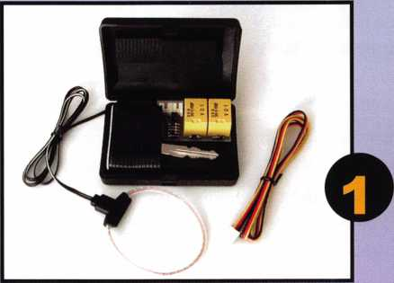

The advent of transponder security, however, adds a

The TBKII is one of two transponder bypass units  
urrently available to the locksmith.

fi

Keynotes

From a mechanical perspective, transponder equipped Fords are available with two different key systems- the 10-Cut and the 8-Cut. From a transponder perspec­tive, three different transponders are used (this does not include the discontinued Motorola chip, used on the 1997/1998 Mark VIII). In order to perform fleet keying, the keys must match on both the mechanical and transponder levels.

System Bypass

Except where noted, these methods are best used on vehicles that use the H73PT, and the H74PT and H86PT key blanks.

Bypass methods actually bypass or circumvent the transponder security that is built into the vehicle. Using these methods, the transponder system is typically left active but ineffective in securing the vehicle.

Two techniques are common in using the bypass method. The first involves taking an operating key and securing it in close proximity to the transponder’s trans­ceiver or antenna ring. Properly placed, any correctly cut mechanical key can then be used to start the car.

Using the same principles for bypass, the second tech­nique involves a transponder bypass unit or kit. These kits are relatively inexpensive (under $50.00) and are much more reliable than the first technique.

Two kits currently available from Lockmasters are the TBKII and the PKF transponder bypass units by Trilogix Electronic Systems, Inc.

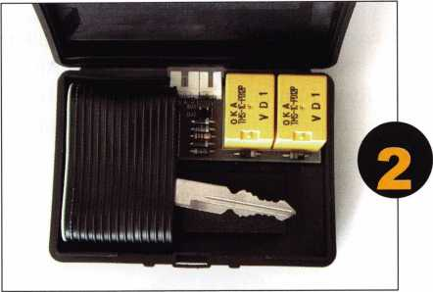

A working key is inserted into the TBKII, and is used to  
transmit the transponder signal from the key.

The TBKII is easy to install and requires one working key. The key is inserted into the TBKII such that the antenna ring envelops the head of the key. (See photo­graph 2.) Power is supplied to the TBKII by connecting the power harness to a positive and negative source.

The “Keysense” connection, used for remote starter applications, is not used. The entire box is then fastened up inside the dash area out of sight. At this point, any correctly cut mechanical key can be used to start the vehicle. The already programmed key within the TBKII provides the transponder signal.

Key Breakdowns Chart

|  |  |  |  |
| --- | --- | --- | --- |
|  | GROUP 1 | GROUP 2 | GROUP 3 |
| TRANSPONDER  CHIP | Texas Instruments Standard | Texas Instruments Encrypted | Texas Instruments Encrypted Wedge |
| KEY BLANK | H73PT  H72PT | H74PT  H86PT | 599114 (Ford Logo) 599179 (Mercury Logo) |
| KEY SYSTEM | 10-Cut  8-Cut | 8-Cut | 8-Cut |
| NOTES | Keys use the same transponder chip, but differ in key system. | The H74 is a longer blank, and can be used in place of the H86PT |  |

Keynotes

Although it operates identically to the TBKII, the PKF unit is a more sophisticated device that does not require the use of an existing programmed key. Instead the PKF provides its own transponder signal that must be programmed into the vehicle, and the wiring is spliced directly into the vehicle’s transceiver harness. Currently, the PKF only works on vehicles using the standard Texas Instrument chip (H72PT and H73PT). An encrypted version for the H74PT and H86PT vehi­cles is expected soon.

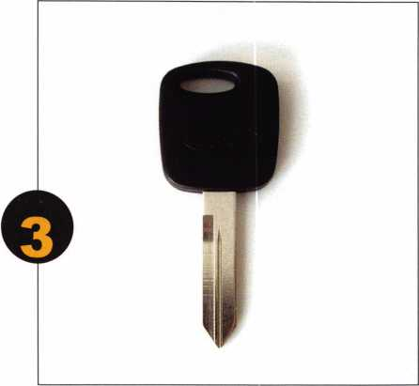

Ford's initial answer to fleet keying involved this specially produced key.

It works only on vehicles that use the H72PT.

For the PKF to operate correctly for fleet keying, the vehicle’s transceiver ring must be disconnected, and the brown wire must be fastened to a constant ground source. Once all connections are made, the transponder signal from the PKF must be programmed to the vehicle using standard Ford duplicate key programming procedures.

If performing onboard programming, two working keys must be present, the vehicle’s transceiver ring must be temporarily connected, and the brown wire of the PKF must be temporarily disconnected. Follow standard onboard programming by inserting the first working key into the ignition lock and turn to the ON position. Wait for the THEFT or security light to go out, turn the lock OFF and remove the key. Insert the second working key

into the ignition lock. Turn the key to the ON position and, again, wait for the THEFT or security light to go out. Turn the lock to OFF and remove the key. Finally, connect the brown wire to ground, insert non-transpon­der mechanical key into the lock and turn to ON. Wait for the THEFT or security light to go out, turn the lock back to OFF and remove the key. Complete the proce­dure by connecting the brown wire to a continuous ground source and disconnecting the transceiver.

(NOTE: the brown wire must be connected and the key turned within 5 seconds. Have a ready ground source available.)

To program using an NGS, make sure the brown wire is connected to a continuous ground and the transceiver is disconnected. Use a mechanical key to turn the lock to the ON position, and use the KEY CODE PROGRAM function to program the PKF to the vehicle.

When using these methods of bypass, two cautions must be observed. First, always have the customer(s) sign a notice that they are aware that the security system of the vehicle has been bypassed and is no longer protecting the vehicle! Second, if using one of the first two techniques (fastening an existing key near the transceiver or using the TBKII), unless the bypass is removed from the vehi­cle, the car owner/user must never use another transpon­der key to start the vehicle. In both techniques, a transponder signal is already being sent to the transceiver. If a second signal is detected, the vehicle’s security sys­tem may register a fault and disable the starting system.

Fleet Key

Only available on vehicles using the H72PT key blank.

It wasn’t soon after the release of Ford’s PATS system that Ford was confronted with the problem of fleet key­ing. With the Ford Grand Marquis being one of the most popular police vehicles to date, fleet keying became a necessity. To address this problem, Ford introduced the Ford Fleet Key. Currently this key is available in limited numbers from Lockmasters or from a Ford dealership as part number 4011-R0241.

Keynotes

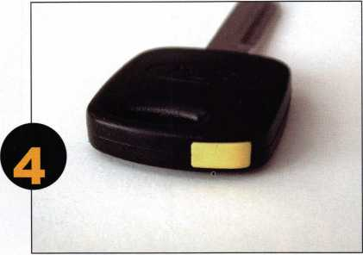

The Ford fleet key is easily identified by this yellow cap.

This key allows fleet keying of only those Ford vehicles using the H72PT key blank, and is easily identified by the yellow cap on top of the key head. (See photographs 3 and 4.)

The principle for using this key is extremely simple. All Fleet Keys have identically coded transponder chips. As such, once a vehicle is programmed to accept this key, any number of Fleet Keys can be cut and used on that vehicle without additional programming. Any vehicle keyed and programmed to accept this key will also operate on all other Fleet Keys that are cut correctly.

Again, make sure the customer signs a notice regarding the changes brought on by using such a key.

Unlimited Key Function

Only available on vehicles using the STRATTEC 599114 or 599176 key blank.

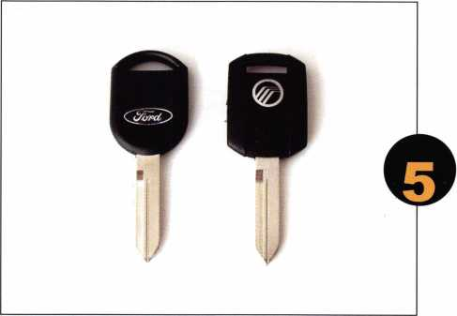

Ford's using these new encrypted keys have access to the Unlimited Key function.  
STRATTEC is the currently the only manufacturer of these keys.

#599114 (Ford Logo), #599176 (Mercury Logo).

Probably the most versatile of all the fleet keying meth­ods was introduced with the Unlimited Key Mode, and first employed on the 2000 Taurus and Sable. This function allows the user to not only program an unlimit­ed number of keys into a single car, but allows them to set up any number of vehicles to accept the same keys. The Unlimited Key Mode also included the debut of the new Ford/Mercury encrypted wedge chip key. To date, all Ford vehicles using these keys, have access to the Unlimited Key function. (See photograph 5.)

To enable and disable the Unlimited Key Mode, Ford’s NGS tool must first be used to enter an eight digit alphanumeric password to activate the Unlimited Key Mode. Despite first impressions, the password is NOT used to stop others from enabling or disabling the Unlimited Key Mode. Instead, it acts much like a mas­ter key and is used to identify the keys and vehicles that are included in a particular fleet. In essence, the pass­word becomes a fleet password.

Once the Unlimited Key Mode is activated, the NGS is then used to enable or disable this function.

When enabled, any number of keys can be programmed into that vehicle. During key programming the pass­word for that fleet is written to the head of the key, allowing it to operate any vehicle within the fleet with­out physically programming them into each vehicle. Adding more vehicles to the fleet is simply a matter of programming the desired vehicles to the same fleet password.

For a more in-depth discussion on Ford fleet keying and other Ford Transponder related topics, see “Saber Tool’s Guide To: Ford’s NGS Programming -v8.0,” available from Lockmasters Inc.

For more information on Saber Tool’s manual, the TBKII and PKF bypass kits, transponder keys, or transponder equipment, contact Lockmasters Inc. at (800) 654-0637. Tom Seroogy can be reached at x342. Q

Keynotes

Auto Lock Repair

**(Tricks of the Trade)**

Red Howell, CRL. Certified ACE Instructor

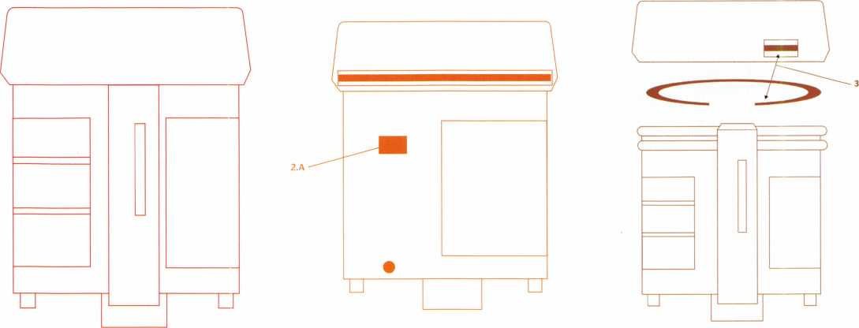

Fig 1

Front side of high-security cylinder using a 4-track  
key with milled cuts

Fig 2

Back side of ignition lock

Fig 3

Keynotes

I

was called out to repair a jammed high security ignition lock (fig. 1)  
on a 1992 BMW 325is. This ignition lock is nicknamed “high secu-  
rity” for the cuts that look like a pattern in the body of the key  
blade. On the phone, the customer told me that he had placed his

wife’s 2001 Volkswagen “high security” key into his BMW ignition lock  
by mistake. The VW key got jammed into the ignition halfway in. At that  
time, he realized he had a mess on his hands. After yanking out his wife’s  
VW key, he inserted his BMW key into the ignition, but the key would  
not turn. The customer asked me if the lock could be repaired.

“Yes,” I replied.

When I arrived at the job site, it was very hot (and even hotter in the car), so I tried to see if there was a faster way to remove the ignition lock.

The old method was to remove the broken ignition lock by drilling out the retaining block (fig 2, part 2.A), with the new #703 drill and sheer

5.C.1

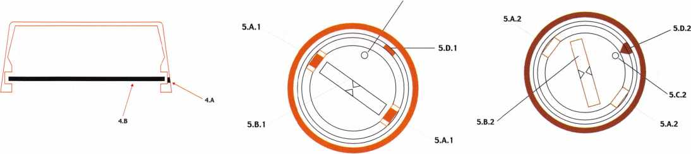

Fig 4

Fig 5.1

Face of ignition lock after cap has been removed

Fig 5.2

Position of keyway after plug has been turned to  
remove jammed ignition lock

Keynotes



“Weighs” in BIG!



Enjoy the new technology from ABUS!  
Using the 83 Series Pinning Window™ Cylinder!

• Z-Bar®

OLD

OLDER

Order the **NEW** “83/55” in any keyway from

your distributor! Receive a **FREE** ABUS ($7.99)

Trigger Lock for each # 83/55 ordered! **That’S a 55% Savings!**

Unique  
“Tear Drop”

Design

* Yale 8®
* Kwikset®
* Schlage C®
* Schlage C-L®
* Corbin®
* Sargent®
* Arrow®
* Russwin®
* Weiser - Falcon®

with

#83/55  
order

**NEW**

**HURRY** while supplies last! Promotion ends - June 30, 2001

For ordering information:

ABUS Lock USA 1-800-352-2287

**[www.abus.com](http://www.abus.com)**

bur sold by RIAG Tools (phone 619/276-4199), and to replace the ignition lock with a new one I had rekeyed. Or, I could have ordered a new one from the BMW dealer using the vehicle identification num­ber. (That process can take three to four days.) The labor will take about one hour and thirty minutes down from two hours from start to finish. You decide what you should charge for that amount of time.

The new way I figured out in that hot car will take forty-five minutes to an hour to finish. Here’s how you do it:

Remove the bottom shour from under the steering column and then remove the rubber ring from around the black cap of the ignition lock. With a cardbid cutter disk, place a small slit into the edge of the black cap (fig 3, parts 3.A) and then work a small pock screwdriver through the slit on the edge of the black cap and depress the “C” ring (fig 4, part

1. B). At the same time, use a medi­um screwdriver to help pop off the black cap (as in fig. 3).

With the black cap removed, place a two-prong tenion wrench into the key hole (fig 5.1, hole 5.C.1), with the retainer block (fig 5.1, part

1. D.1). Insert a small wire in the wire hole (fig 5.2, part 5.C.2), pull down the retainer block (fig. 5.2, part 5.D.2) and remove the ignition lock.

That will get it out of there pretty quickly for you. From there, you repair the lock as you normally would, and simply re-install it back into the car. It saves you time, and therefore money, and that’s what tricks of the trade are all about. Q

Keynotes

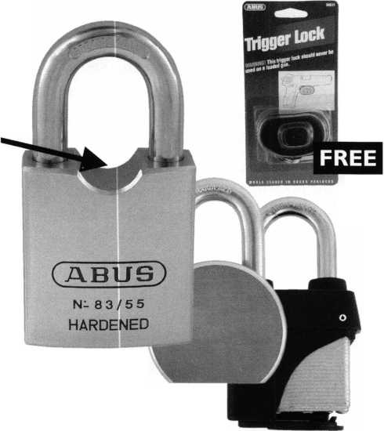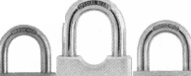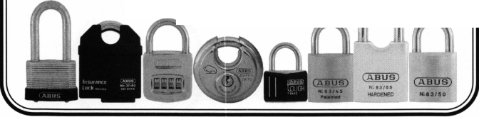

Dec. 2001 Dallas, TX

Jan. 2002 Orlando, FL

Feb. 2002 San Francisco, CA

May 2002 Chicago, IL

June 2002 Somerset, NJ

Aug. 2002 Atlanta, GA

Sept. 2002 Anaheim, CA

For additional  
information on the dates &  
locations of the PUREAuto  
Automotive Weekend  
nearest you, contact  
LOCKMASTERS at  
**800.654.0637 ext 328,** or  
see our schedule on  
**[www.lockmasters.com](http://www.lockmasters.com)**

**AUTOMOTIVE AND LOCKSMITH TOOL RESOURCE**

**Now join Lockmasters Inc. as we tour the United States with our**

**Transponder Equipment  
Transponder Keys  
STRATTEC  
ASP • BWD Locks  
Keys & Service Kits  
A-1 Tools • Able  
Keedex • HPC  
Sieveking and More**

**AUTOMOTIVE WEEKENDS!**

**From the basics to the latest in**

**HIGH-TECH AUTOMOTIVE LOCKSMITHING,**

**get your fill of Transponder Technology, Auto Opening, High Security  
Automotive, Key Generation and the newest tools to do the job fast!**

**Ilco • HPC • ITL  
and Rytan**

**HPS and Tech Train**

**Tom Seroogy  
Tom Lynch • Randy Maze  
and More**

**LKM2690 High Security Flip-Pick**

5085 Danville Road • Nicholasville, KY 40356 • 859.885.6041- • Fax 859.885.7093

**800.654.0637 ext 328 • [www.Iockmasters.com](http://www.Iockmasters.com)**

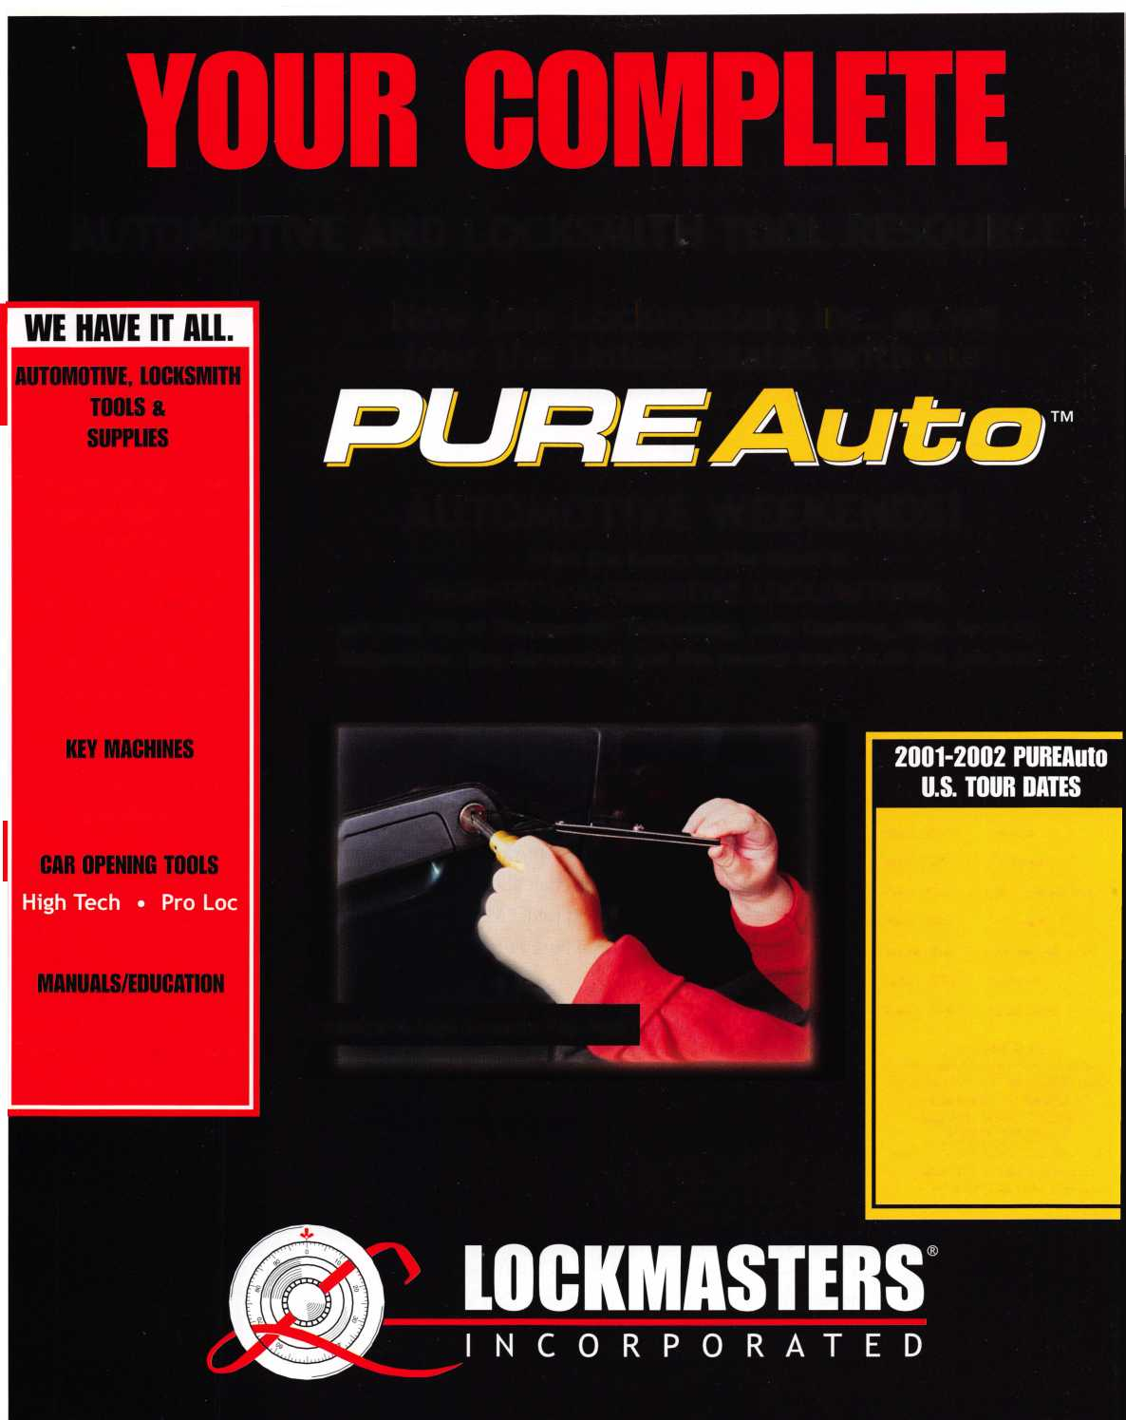

Starting Out

in Locksmithing

By Merritt Perkins

H

ow should a person learn locksmithing? The traditional way is  
by apprenticeship. The master has an opportunity to get well  
acquainted with the apprentice and familiar with his character.

Frederick Clement of Gary, IN, told of his experience as an  
apprentice in Austria. Before a boy could become an apprentice, the  
character of his family was investigated and if anyone in the family had  
a defect in their character or a record of crime or dishonesty, he would  
be refused.

He had to get up early in the morning and start the fire in the forge and  
prepare the shop for the day’s work. After completing his apprentice-  
ship, he was given a suit of clothes and he started out as a journeyman  
to get experience in other shops. There were hostels where he could stay  
on his trip and he would apply to other shops to get experience there.

He would be given some steel and told, “Make your tools.” His chisel  
had to be hard enough to cut iron but not brittle enough to break, other-  
wise, no job. v

The black metal is iron and smith comes from smite mean-  
ing to strike. The “blacksmith” shapes iron by heating it  
in a forge and striking it with a hammer. The iron used by  
blacksmiths was wrought iron which has not been made since  
the 1920s.

Wrought iron was made by heating molten pig iron in a  
reverberatory furnace where the heat from the burning fuel

gases is reflected from the ceiling of the furnace. The  
molten iron is on a bed of iron oxide so that as the oxy-

gen in the oxide combines with carbon in the molten iron. The

melting temperature increases as the carbon is burned out and the  
iron becomes pasty. The iron is worked around into balls with

a little slag from the silica flux mixed in. These balls are  
then squeezed and formed into bars and rolled to the

Keynotes



desired size. Wrought iron can be forged into different shapes and welded. If you cut a bar of wrought iron, the gray fibers of slag running lengthwise can be seen. It is nearly pure iron, but the slag fibers make it more resistant to rust than low carbon steel, the best substitute available today.

Few locksmiths today own a forge, anvil, blacksmith’s hammer, tongs, or other black­smith’s tools — or have occasion to use them.

In case of fire, the light bulbs may be black  
with soot, and the air full of smoke. You  
can’t fumble around for a key in the

Today, locksmiths work with metals: brass, steel, die castings, and plastics and wood.  
They are often responsible for large installations involving many locks and keys and  
involving master keyed systems. They need to have a knowledge of many makes and

models of locks and key blanks. They need  
be familiar with codes and standards  
and the operation of the government,  
its laws and regulations and legal

matters. They need to make sure  
that locks are suitable for the  
application where they are  
used and to be able to repair,  
replace, or install locks.

They need to keep records  
of locks and keys and advise  
management on how to control  
to whom keys are issued.

Computers are widely used by

locksmiths in keeping records of their  
work and in managing their business.

The locksmith is responsible for the security  
of his customers and the community. He gets to  
know people and their reputations. He could supply

keys and safe combinations that would give access to  
peoples’ valuables and documents. He is responsible for  
their safety and security; not only for keeping intruders  
out but also allowing the occupants an exit in an emer-  
gency. A double cylinder deadlock installed on the front  
door of a house can result in the following scenario:

There was a fire and the occupants tried to escape, but  
they dropped the key on the floor. The father and children  
were found dead by the door; the wife escaped by  
another route.

Keynotes



*SPEEDYPIK*

THE AUTOMATIC  
KEY IDENTIFICATION  
SYSTEM

* Preprogrammed database with full side view
* Automatic inventory control and reorder program
* Create your own database(s) to match your keyboard
* Hire inexperienced personnel without training

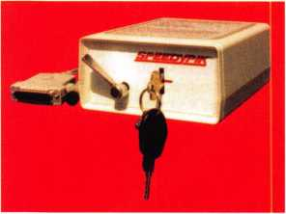

THE AUTOMATIC  
KEY DECODER SYSTEM

* Eliminates measuring each cut in a key
* Eliminates looking in pinning charts
* Portable, hand-held, battery-oper­ated
* Connects to your computer (serial port)
* Complete scan & readout in seconds

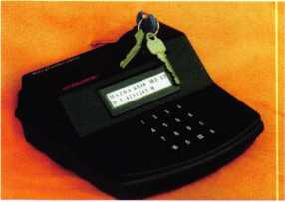

Phone: 617-567-1111  
Fax: 617-277-7777

E-Mail: SPEEDYPIK @  
AOL.COM

[www.SPEEDYPIK.com](http://www.SPEEDYPIK.com)

darkness. You do not dare to breathe the smoke so  
you have only a few seconds to get to fresh air  
before you die.

If a school is having trouble with stealing from lockers  
and classrooms, they shouldn’t loan out a master key  
when someone is locked out of a locker. This is poor  
security; someone should go with the person who  
claims to be locked out after checking that he is author-  
ized to enter the locker, and never let the master key out  
of their possession — or even show it.

Many stores have key duplicating machines and the  
management copies keys as a way to make money,  
sometimes with little regard for responsibility. If you do  
not stock all of the blanks for sectional keyways (only  
the master blank), you really should. If a disreputable  
person managed to get possession of a building master  
key, they would be proud that they could copy it, not  
knowing what it was or what it could be used for. The  
copy would give an unauthorized person access to the  
building and rooms.

In one case a long series of thefts from a school system  
was solved when a schoolboy was caught because he had  
an unauthorized master key. The stolen articles recov-  
ered, including an expensive tape recorder found more  
than 100 miles away, filled the police property room.

The son of a school official went to a locksmith and had  
a key duplicated. A little later, the owner of a store went  
to the locksmith and asked, “Have you made a key like  
this recently?'”

“Yes, I just made one for...”

“I just fired him.”

A locksmith was working on locks at a school when a  
schoolboy came over and started watching him. They  
got acquainted and the locksmith invited the boy to visit  
his shop. The boy spent a lot of time there and learned  
how to complete different jobs. He had taken shop  
courses in school and learned how to use of tools and  
make things. The boy reached the place where he could  
manage the shop.

Keynotes

Later, he started his  
own shop and made  
his own furniture. The  
last I knew he was a sales-  
man for a large locksmithing  
distributor. Those who learn by  
working in locksmith shops or

serving an apprenticeship get to know  
someone who they can turn to for advice  
or help.

Locksmiths need to communicate with other lock-  
smiths, exchange information, and help each other when

they have problems. Unfortunately, there is a great deal of envy  
and jealousy especially among those who feel inferior. Many people  
who know little or nothing about locksmithing suggest that beginners  
take up locksmithing as an occupation. I once heard it suggested that  
prisoners soon to be released from prison be taught locksmithing so that  
they would have an occupation. Correspondence courses are advertised  
in magazines whose readers have little metalworking skill or knowl-  
edge. A student is told that as soon as he has completed the course and

has a certificate he can go into business for himself. Before a person

is encouraged to take up locksmithing or invited to join an  
organization his qualifications should include honesty,  
patience, self-discipline and the ability to keep confiden-  
tial information confidential.

Unfortunately the information available to the public  
too often comes from someone with little knowledge of  
locksmithing or the responsibility of locksmiths. Q

Keynotes

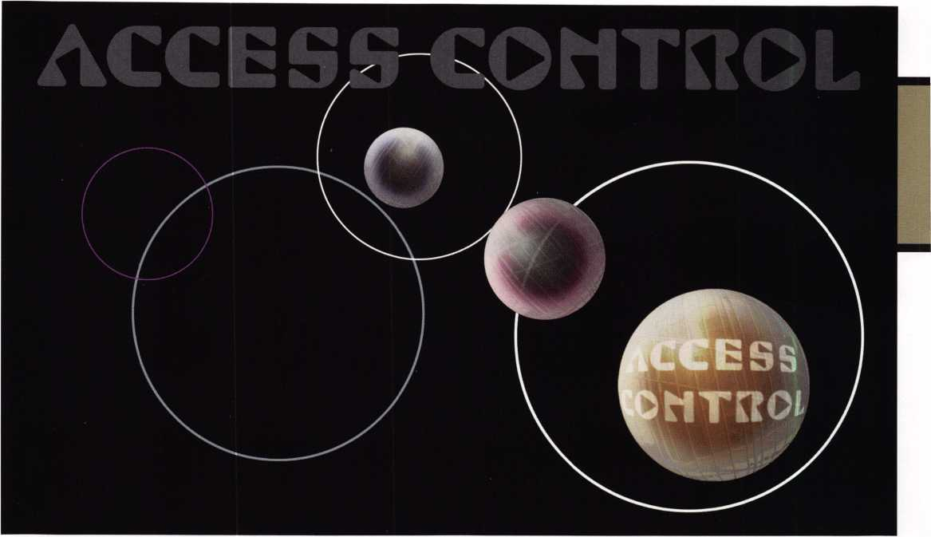

T

hroughout it’s history, Securitron has become known as a problem

solver within the security industry. The solutions have taken the form  
of everything from the Magnalock® series of electromagnetic locks  
to the unparalleled MagnaCare (Lifetime Replacement Warranty).

In 1999, the company addressed the problems that traditional electric strikes  
present to electric locking.

Electric strikes are sometimes inaccurately referred to as electric locking devices when, in fact, they are door latch releasing devices. The security effect comes from the fact that the latch is mechanically locked from the outside: anyone try­ing to enter is unable to turn the door knob or door lever. When someone pulls on the door in an attempt to open it, the door is held secure by the latch hitting a pivoting plate called the keeper, which is the crucial component within an elec­tric strike. When the electric strike is activated, the keeper is electrically released so that it pivots out of the way of the latch and the door may be opened. The door remains locked mechanically. The doorknob is never turned from the out­side and the latch is never retracted. From the inside, however, free exit is possi-

Keynotes

Electric strikes are sometimes inaccurately referred to as electric locking devices when, if fact, they are

door latch releasing devices.

ble by simply turning the doorknob and retracting the latch because the electric strike is not activated and the keeper stays in place.

In contrast to electronic strikes that utilize a keeper, the original UnLatch® is designed without a keeper, instead using a motor-driven plunger to push the latch back into the lock body. By redesigning the strike without a keeper, the Securitron engineers not only created an electronic strike that could withstand pre-loading but they also made it possible to fit an elec­tronic strike in a standard 4 7/8” cutout. However, the original UnLatch® was designed for only one type of lock—the cylindrical or tubular type of lock.

After receiving overwhelming response to the original UnLatch  
Securitron realized there was no electronic strike that would

work just as easily with a completely different set of

latches-the mortise-types. Unlike a cylindrical or  
tubular type lock, a mortise lock includes a latch  
and separate dead latch pin. When the lock is in  
the closed position, the latch is extended,  
thereby securing the door with the latch inter-  
nally pinned by the deadlatch pin. While this  
makes for a very secure type of latch, there  
is no standard of design, and the result is a  
staggering array of latch and dead latch pin  
configurations within a standard 4 7/8” strike  
size. With the lack of uniform mortise-type  
locks, conventional mortise electric strikes  
come in a complex array of models which can be  
confusing and costly to inventory. Preliminary

designs of the Mortise UnLatch® called for multiple

versions as well, but Securitron’s engineers were able to  
devise a better, more universal way to bring UnLatch®  
technology to mortise locks. The result is a new patent and the MUNL.

can be set to fjt

3

Keynotes

2

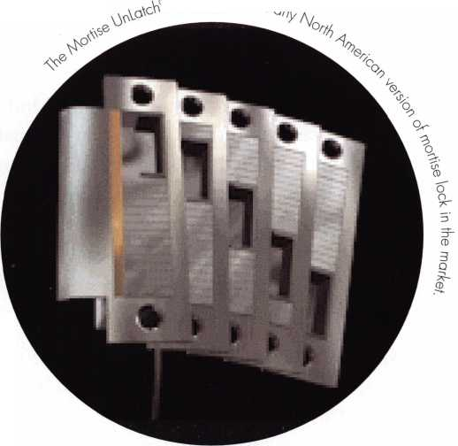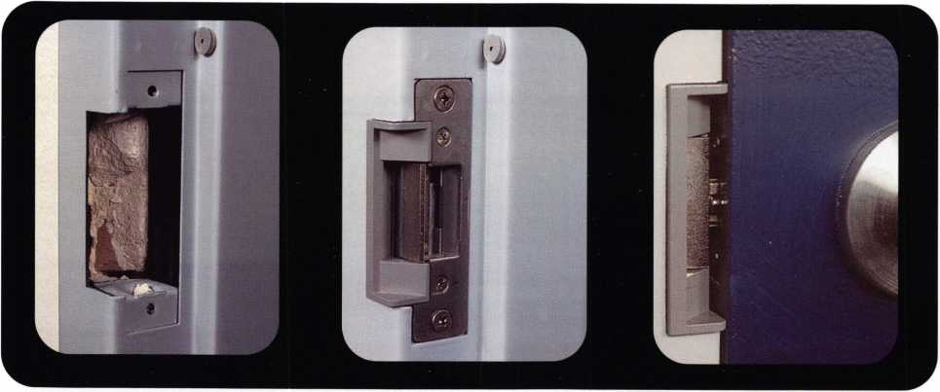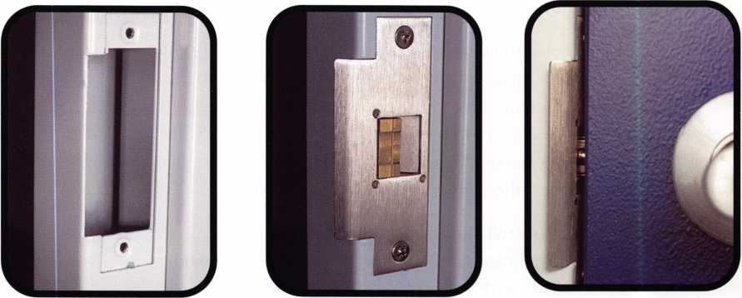

Through a unique design approach, the Mortise UnLatch® can be set to fit any North American version of mortise lock in the market. No matter what the configuration of the latch and dead latch pin, the MUNL can be adjusted by using only a screwdriver and an alien wrench. Simply remove the outer cover and the shield off the strike, slide the dead latch fingers as necessary and replace the shield and outer cover. In a new construction project, this adjustability means the designer can choose any mortise-type lock on the market, and doesn’t have to worry about which mortise-type electronic strike will work because the installer in the field sets the MUNL. In a retrofit project, the same MUNL model can be used throughout.

An electronic strike such as the UnLatch® or Mortise UnLatch® is the perfect problem solver for retrofit upgrades from a mechanical lock. Since the latch is electrified, the lock doesn’t need to be. This eliminates the problem of routing out the door to install an electric lock, and it elim­inates problems if something goes wrong. If an electric lock malfunctions, the entire lock needs to be removed from the door, occasionally necessitating removal of the door itself. With the UNL or the MUNL, the faulty strike is simply unscrewed from the doorjamb and the attached wire is disconnected. Plus, the MagnaCare (Lifetime Replacement Warranty covers all Securitron products, so if one does malfunction, it will be replaced at no cost, no questions asked, on a lifetime basis).

Keynotes

Another problem installers run into is the issue of cutting the doorjamb to accommodate a typi­cal electric strike. Securitron’s engineers recognized this and solved the problem by designing the Mortise UnLatch® to fit in a standard ANSI 4 7/8” strike space like the original UnLatch®- without any extra routing, cutting or modifications. This not only preserves the visual appeal of the door, but also the strength of the jamb. And because the jamb is not cut, there are no issues of reduced “forcing strength”. Forcing strength is the amount of pressure required to break the keeper free from it lock position, lock before it is electrified is maintained.

With conventional electric strikes, the cut-out doorjamb is a dead giveaway to a potential van­dal that an electric strike is being used. With both the original UnLatch® and the Mortise UnLatch®, the strike is fully concealed within the doorjamb, giving the appearance of a stan­dard strike plate. By making both the UNL and the MUNL fit in a standard cutout, Securitron is solving a problem not only of esthetics and jamb strength, but also of criminal deterrence.

With only one choice to make between 12 or 24VDC, the UNL and the MUNL are the easiest strikes on the market to specify. Plus, Obecause of the innovative “keeper-free” design, both the original UnLatch® and the Mortise UnLatch® are fully covered by Securitron’s award-winning MagnaCare (Lifetime Replacement Warranty).

To find out more about the UnLatch® family of electronic strikes by Securitron, please visit <http://www.securitron.com> or call 1-800-624-5625 and speak with our Sales and Tech Support team. Q

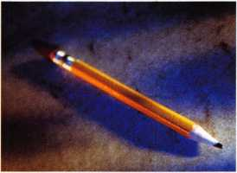

This is a basic locksmithing training course sponsored by FVTC’s Security and Crime Prevention  
Department and conducted by ALOA ACE instructors. Designed for the locksmith shop owner  
who would like to provide entry-level training for new apprentice locksmiths as well as those who

would like to receive professional training that will enable employment with a professional locksmith. The course will allow the student  
to gain enough knowledge to make them a starting apprentice in an existing shop. Job placement locations will be made available at the  
time of the class.

Locksmith Training

6-Day Program • Career Change in One Week • January 21 -26, 2002

To maintain quality the course enrollment will be capped at 12 students. Enroll early!

Curriculum includes:

Key Blank Identification and Duplication Lockset Servicing, Functions, Finishes

Key Codes and Code Equipment Life Safety Codes

Basic Master Keying Lock Pick Opening Techniques

All tools and equipment will be made available for use during training.

Class Flours: 8:30 am to 5:00 pm every day Class Attire: Shop clothes Course Tuition: $995.00

Pin and Disc Cylinder Servicing Door Closers

Key Impressing Lockset ,nsta||ation

Lock By-Pass Techniques Cabinet, Fumiture> Mai|box Locks

Exit Flardware

Course Enrollment: See Linda Buck in the Criminal Justice Center

or call 920-735-2406

Note: Enrollment deadline is Wednesday, January 2, 2002

Keynotes

Nowadays we hear a lot about

investigative locksmithing and forensics.

The International Association of Investigative Locksmiths is growing rapidly

and becoming well known around the world. How does that affect us as locksmiths and safe technicians or does it? I believe there is a definite need for those who are qualified safe techs and have some understanding of investigative techniques. In this article I will try to give you some idea as to how you might use your skills, knowledge and training to expand your horizons and open the door for some lucrative work, if you are interested. I will also attempt to present some scenarios to challenge you (maybe) and determine if you may be interested in getting into this field.

29

Keynotes

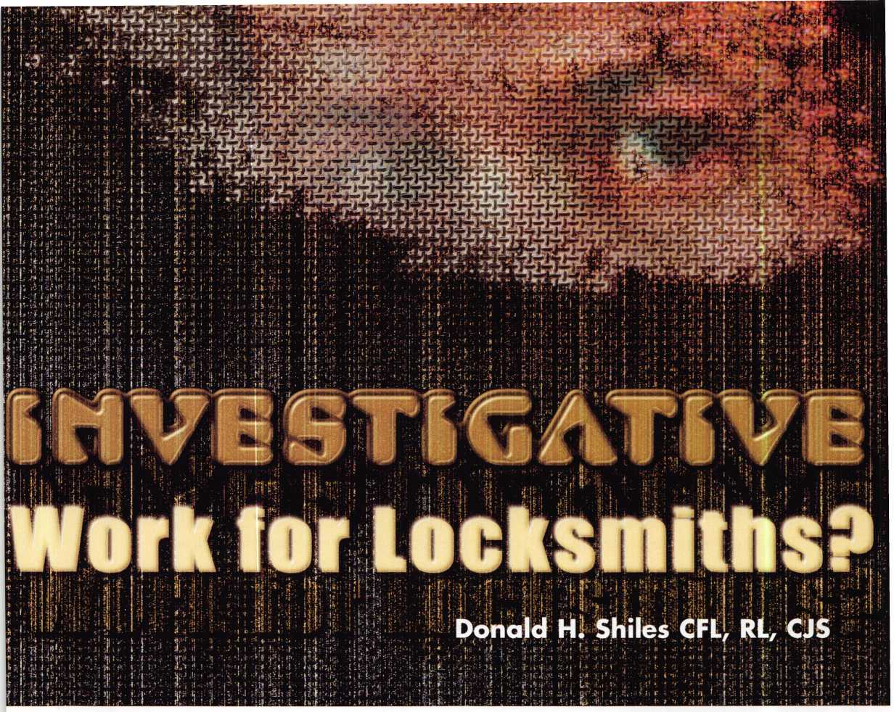

Window

To begin with. Investigative Locksmithing is a fancy  
title for some of the things that we have all done over the  
years but it allows us to do them in a formal, organized  
manner and get paid accordingly. The field of Investigative  
Locksmithing is nothing more than applying our knowl-  
edge in a way to assist an investigator, insurance represen-  
tative or private party determine what really happened in  
the case of a loss of some type. The questions we try to  
answer are: Was it an inside job by someone having  
authorized access? Is it an actual burglary or unauthorized  
entry? If it is, how was it done? If possible, what kind of  
information can we gain about the person(s) who did it;  
was it an amateur, or a professional? Did they use High  
Tech tools or tools readily available to anyone? If we can  
answer any of these questions we can be of invaluable  
assistance to the authorities.

I will grant you that investigating safe burglaries or thefts  
from safes is more difficult than determining whether or  
not a lock was opened with something other than a working  
key. However, as you will see from these examples, there  
are things we can determine and testify to. Let’s look at a  
few examples, some of which are taken from actual cases.

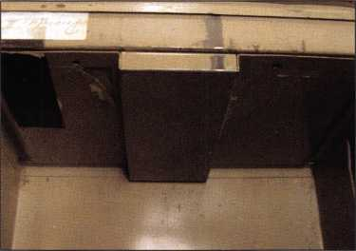

Case #1 . As an investigator you are called in by the  
police to determine whether a safe had actually been  
broken into or whether it had been an attempt to make  
it appear that way. The scene is a small office with a  
fireproof safe, let’s say a Major Model 3016. Upon your  
arrival the safe is in the far corner with the door standing  
open. It is equipped with an S&G 6730 combo lock.  
There has been a 3/8” hole drilled to the right of the dial.  
Drill residue is lying on the ground below the door. (See

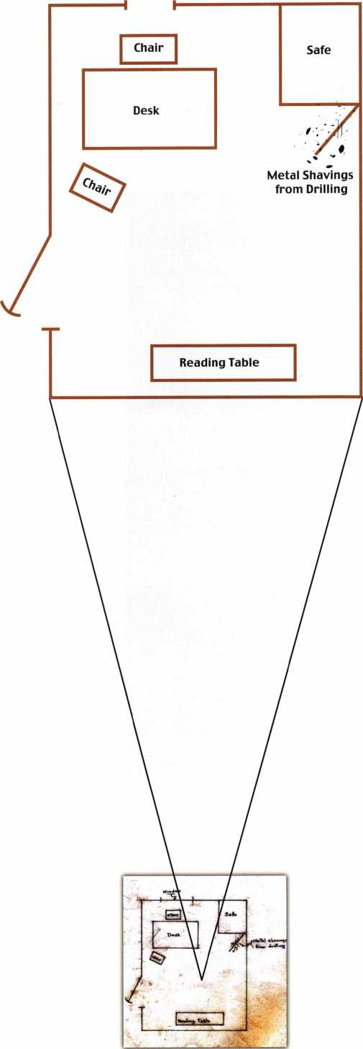

El

Keynotes

3

Investigative Locksmithing is a fancy title for some of the things we have all done over the years but it allows us to do them in a formal, organized manner and get paid accordingly.



Keynotes

Sketch) Was this a forced entry or an inside job?

See end of article for the solution.

Case #2 . A GSA Mosler 5 drawer Class 6 Black  
Label Security Container has been found open and  
classified documents are missing. The lock is a Mosler  
302 MR lock. There has been a hole drilled in the side  
of the safe in the approximate position to provide a  
scope hole to recover the combination in order to open  
the safe. Was this a forced entry or was the combina-  
tion used? See end of article for explanation.

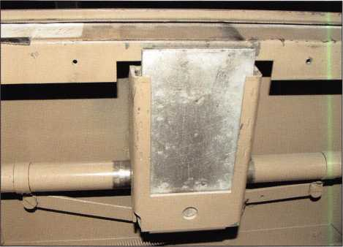

Case #3. A Sentry wall safe equipped with a com-  
bination lock and a key operated lock. Safe was found  
open and valuables missing. Police are assuming it  
was an inside job because there is no sign of forced  
entry. What information could you give them as to  
whether this could have been an unlawful entry or  
not? See end of article for possible answers.

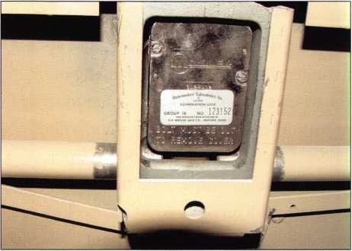

Before you get to my solutions, ask yourself if this was interesting to you. If it was, would this be something you would like to do. If you answer yes to these two questions, maybe Investigative Locksmithing is for you. Only you know the answer to that. Unless you have more safe jobs than you can handle and you have as much income as you would like, then you probably should consider getting involved. You can contact me for more information at [donshiles@aol.com](mailto:donshiles@aol.com), or call me at 4109-674-7721 and I will be glad to answer any of your questions, or at least try.

Solution to Case #\: There are two dead give-aways on this one proving that it was an inside job. The first one is the debris at the bottom of the open door. This proves the safe was drilled with the door in that position, in other words, it was already open when drilled. The second thing is, there is no known defeat technology that allows you to open this safe and lock combination by drilling to the right of the dial on a right hand mounted lock. All linkage is to the left. In the real case the police determined that the assistant manager had stolen the money and drilled the hole in an attempt to convince the police there had been a burglary.

Solution to Case #2: It is obvious that this was also an inside job since there is no way to scope a GSA security container to begin with. (See photos 1, 2 & 3) The lock is protected on all six sides by drill resistant hard plate as prescribed by the GSA certification requirements, so you cannot see the back plate of the lock.

If someone should have drilled through the side hard plate with a small enough scope to see the change key hole (which I don’t believe is possible), they would have had another problem. The 302 MR Mosler Lock is a hand change lock, so there is no change key hole. Your knowledge of safe and lock construction makes this an easy case but is a total mystery to most law enforcement officers.

Solution to Case #3: While it must be considered that someone with access to the key and the combination could have opened the safe, you would be required to inform the police that these key locks are relatively easy to pick or impression. Your investigation of the face of the lock and the four sets of pins will reveal any sign of an attempt to open the lock without a working key. A strong magnifying glass or handheld microscope will be all you would need to conduct this examination. Of course the combination lock, being a direct entry type lock is easily manipulated open, which would not leave any marks unless someone had attached a needle or laser to the dial to assist in manipulation. This might leave marks on the exterior of the dial that you could find and identify. While this is all relatively easy to do for us, it is almost black magic to a police officer.

In this case the evidence would determine for you whether it was a burglary or an inside job.

I hope this has given you something to think about and just maybe it is something you would like to do.

The insurance companies are looking for people like you to help them out and the police will be also, once you educate them to your capabilities. Good luck in whatever you decide. Q

Contact

the Author • Donald H. Slides CFL, RL, CJS • 410-674-7721 • [donshilcs@aol.com](mailto:donshilcs@aol.com)



Keynotes

AMSEC

Gun Safe,

You Be the

u

Safe work comes to me in many forms. Changing the combina­tion and servicing the lock or boltworks is the most common. Drilling or opening a safe might be next most common call. Working on hinges, springs, or other parts is usually way down the list of call outs. This time the customer called saying their door had "sprung or something" and they could no longer shut the door properly on their big gun safe. They were leaving on vacation and wanted the safe working properly before they left. When I got there I found a four year old Amsec F7240, the door had dropped over a 1/4". I called Amsec to ask if they were hav­ing a problem with this design and had come up with a repair solution already or if this was a unique problem. I spoke with John in technical support who indicated this was the first he had heard of this problem but would check with others to see if this truly was a first. I took a few pictures to post on Clearstar (the Internet forum) to see if anyone else had a found this problem and come up with a solution. Amsec makes some great safes; in this case I think I found a design flaw, but I'll let you see the pic­tures and allow you to judge for yourself.



The first 3 photos are what I found when I arrived. These are also the pictures I posted on Clearstar. Photo 1 is the outside of the open door. Photo 2 is of the bottom corner of the door against the safe bottom. Photo 3 takes us inside for a look at the hinge; the mating surface is badly worn. The next day, armed with some suggestions from Clearstar I decided to remove the door to see if I could find and correct the problem. My first step was to strap the door to a pair of Roll-O-Lifts as seen in photo 4. There are two of them strapped to the door. These lifts can be invaluable for mov­ing safes or in this case lifting a door. Before the door could be raised I needed to remove a steel plate which blocked the door from being lifted. I used a Dremel tool with a cutoff wheel to grind off the welds. Next the door was lifted with the jacks.

You can see the wear on the hinge block in photo 5. This wear in my opinion is due to the design of the hinge. The hinge pin is welded to the 3/16" vertical strap of the hinge. This means the only bearing surface from the door is this strap. Over time it digs a groove through the bearing washer as seen in photo 6. It then starts digging in to the top of the hinge block causing the door to drop.

By Greg Perry, CML, CPS



Keynotes

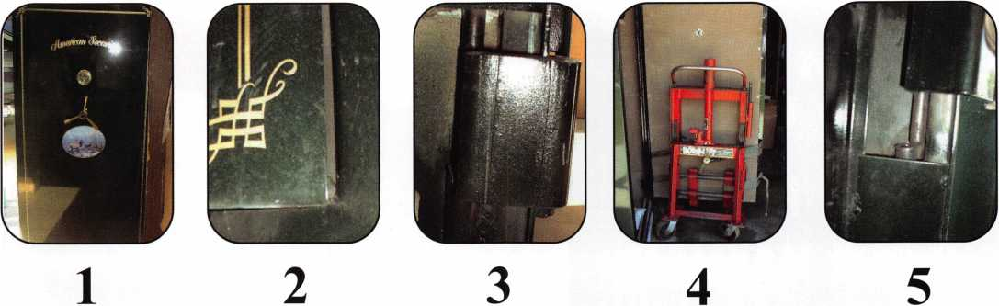

I was unable to maneuver the door out of the opening so I moved to the side and flattened the top of the hinge blocks that are welded to the safe body with a Dremel tool. Next I used two steel machine bushings (fancy word for a tight fitting washer) and an oillite thrust bearing seen in photo 7 to create enough lift for the door. In the future I would use needle bearings similar to the ones used between the vise and the wing nut of a key machine. This time I didn't have any in stock or any available locally. I held the bearing package in place with a small magnet as I repositioned the door and dropped it back into the hinge blocks as seen in photo 8. Photo 9 shows the result, the door portion of the hinge is still a little sloped causing the washer stack to tilt slightly. I think using three washers instead of one will help with the wear and perhaps make this a more lasting repair then the original. Photo 10 is simply a reference shot of what the inside of the door looks like.

The following week I received a follow up call from John in technical support at Amsec. He restated this was a first for them and that his guess was the customer did something to create the problem. Their recommendation was to remove the door and weld in new hinges. Curious I asked how to actually get the door

out of the opening since I could not maneuver it out of the open­ing while it was on the Roll-O-Lifts. He transferred me to Randy, also in technical support and after explaining the prob­lem to him, he indicated he was working on a similar problem with another gun safe. He faxed me a drawing of a repair they had come up with using a block, a ball bearing, a pin and some shims to hold the pin in place under the bottom hinge pin (con­tact AMSEC if you need a copy of this drawing). A similar design was suggested on Clearstar a few days latter. Randy is sending me the repair kit they designed. I'll pass it on for the customer to use if my repair wears out.

The customer a machinist/home gunsmith by trade and feels the same way I do. 3/16" is not enough of a surface for a door of this size to hinge on especially with only a single steel washer as a bearing. Three layers of washer should help prevent the wear. In all fairness to Amsec the door is four years old, and this cus­tomer opens their safe more then the average user, but I would like to think a hinge should last longer then four years. Perhaps I’m asking too much, but I think it is a problem that will come up more often as time goes by. Now that you've seen the pictures and read the story, what's your verdict? Q

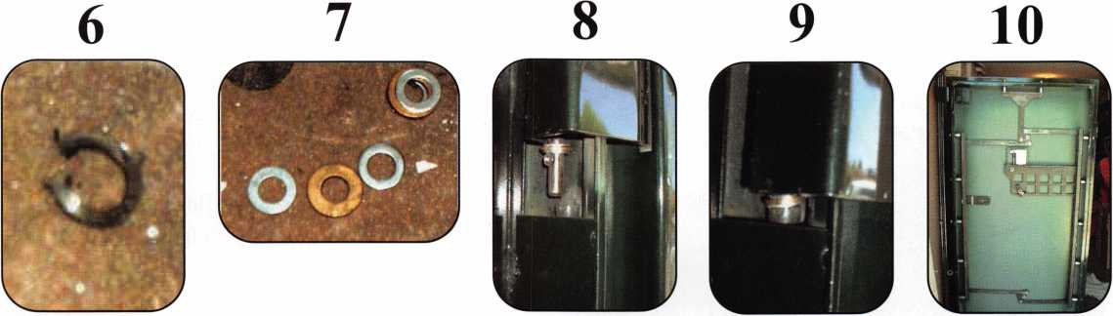

Keynotes

**Safes In Stock. Ready to Ship**

**amsec FreKing Oaidall HAYMAN**

**MEILINK** y/CTOR

MOR^ROFT^^REEFREIGHT

pURfHol

f WHOLESALE SERVICE I*

**800-848-9790**

***Our business is helping you sell more safes!***

Oust a c fief away fromyour

security door hardware needs:

[www.jlmwholesale.com](http://www.jlmwholesale.com)

OVefsite features:

Detailed product information.

Search capabilities on each page. Check box to display only in stock items. New quick links. Extremely user friendly. Downloadable interactive product catalog.

1 HARDWARE FOR THE MEW l\

Oxford, Ml 1-800-522-2940 **.**

Charlotte, ***nc*** i-800-768-6050**.** *Order Online* -

[www.jlmwholesale.com](http://www.jlmwholesale.com) ^ree dreijfa!

AGAMS RITE • ALARM LOCK • ALTRONIX • DYNALOCK • ELK • E8SEX ELECTRONICS • FOLGER ADAM SECURITY • GLYNN JOHNSON H.E.S. • LEI. • LCN CLOSERS • LOCKNETICS SECURITY ENGINEERING INC • ROTON • SCHLAGE • SECURAKEY • SECURITRON SECURITY DOOR CONTROLS * SELECT PRODUCTS • SIMPLEX • SIGNAL CABLE • TRIMEC • TRINE • VON DUPRIN



**JOIN**

The Legislative Action Network

**TODAY!**

As we continue to expand our resources and become more competetive in the legislative arena, we need support to match our successes. You can help! With a donation as little as 14.95 to the Legislative Fund, you can start a rewarding membership in the Legislative Action Network.

Members who donate $100 or more become Legislative Action Network Council Members and receive benefits such as: direct input in the legislative strategic plan; discounts on ALOA store items; 10% rebate on all ACE classes and complimentary Legislative Convention mer­chandise.

Contact Tim McMullen, Government Affairs Manager at [tim@aloa.org](mailto:tim@aloa.org).

35

Keynotes

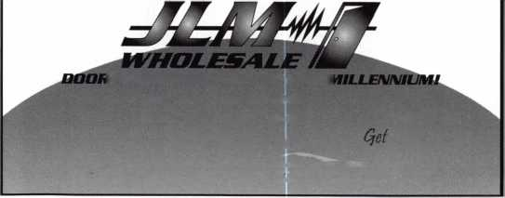

Just a Few

of the Many Titles Available...

PRP Resource Guide $25.00

Fundamentals of Master Keying $55.00

Simplex Unican

Manipulation Manual $39.00

Locksmithing:

From Apprentice to Master $27.00

Logical Lock Diagnostics $29.95

Safe Deposit Depth and

Space Manual $ 1 20.00

Safe Deposit adapter kit for use with the

Safe Deposit Depth and Space Manual

and the HPC 1 200CM $85.00

Safe Technicians

Reference Manual $156.00

How to Pick Lever Locks $19.95

**Visit our Website or call to place your order today!**

**[www.aloa.org](http://www.aloa.org) • (214)827-1701 x 23 • (800)532-2562 x23**

Announcing "Professional  
Locksmiths Day"

A Proclamation from the state is a great way to edu-  
cate the public and the legislature on the important  
role you play in today's security environment

In recent years, chapters and associations have become more active  
in getting their state to recognize "Professional Locksmiths Day."

This revival was begun by Lee Griggs, CML of the South Carolina

Locksmith Association and picked up on by John  
Dorsey, CML of the Indianhead chapter of ALOA  
(See Keynotes, October 2000 issue). "I took the bull  
by the horns and found a lamb," says John on the  
ease in which getting a proclamation from the  
Governor's office truly is. But why bother with one?

Why do we need a "Professional Locksmiths Day"?

For two reasons, the public and the legislature.

Many people still do not fully understand the breadth  
of the work locksmiths do. "Cutting keys" seem to  
be our pigeon hole in life. A proclamation by the  
state can be a wonderful tool in marketing and pro-  
moting the profession by saying exactly what you do  
in each "WHEREAS". You can take that proclama-  
tion and submit it to just about any newspaper, and  
they will more than likely either run a story on it, or  
at least print the proclamation itself. Its better than  
any yellow page ad!

Also, it helps legislators understand what we do, especially in the totality of the security industry. Many times bills are introduced by other industries that effects locksmithing, but a state representative or senator does not understand why locksmiths should be concerned. This is because they too, do not understand what we do.

But where does one start? A proclamation in most states is treated just like a piece of legislation. You will have to author it, hand it over to your representatives, they introduce it, its voted on and then signed by the Governor. "It takes a little while to get the language right on what the profession is about. " says Bill Smith, RL of the Fox Valley Chapter of ALOA, who worked on this year's proclamation for Wisconsin.

Here's the "How To" guide on getting a proclamation passed:

• When should be "Professional Locksmiths Day". October is the National Crime Prevention Council's ([www.ncpc.org](http://www.ncpc.org)) "National

Crime Prevention Month." Find out when your state's month is  
by calling the Governor's office, and plan accordingly.  
Remember, most state legislatures only run from January to June  
each year, so you must get your proclamation in early (pre-fil-  
ing in November or December the year before is always a  
good idea).

* Write the proclamation yourself (or have a committee work on  
  it). Make sure that you are explaining all facets of what lock-  
  smiths do, and promote ALL associations in the state. Here is  
  just one example of what you might want to say:

A PROCLAMATION

WHEREAS, locksmiths operate in the public trust as securi-  
ty professionals to secure and protect property and per-  
sons; and

WHEREAS, locks, deadbolts and other locking devices  
used to safeguard homes, businesses, and vehicles are  
installed, modified and repaired by trained professional  
locksmiths; and

WHEREAS, as security professionals dealing with high-  
security keying systems, electronic access control systems,  
computerized systems, automobile anti-theft ignition sys-  
tems, state building codes, life safety codes and the ADA  
codes, professional locksmiths help ensure the safety and  
continued well being of the citizens of (name of state); and

WHEREAS, the members of the (names of all locksmith  
associations in the state) are highly qualified security pro-  
fessionals engaged in consulting, sales, installation and

maintenance of locks, keys, safes, premises security■ access controls, and  
other security related endeavors; and

j

WHEREAS, professional locksmiths are genuinely associated with crime pre­vention and work hand in hand with law enforcement;

NOW' THEREFORE, /, (Governor's name), Governor of the State of (name of \ state), do hereby proclaim (date of recognized day) as

| PROFESSIONAL LOCKSMITHS DAY

In the State of (name of state) to recognize the positive impact of professional locksmiths on the continued security of the citizens of this state.

* Ideally you would go to your own state representative and sen­ator to introduce the bills (in some states you only need one side to introduce it, but its always a good idea to submit them to both). Its even better if your state representative and senator are from the party in power for that branch. If not, you may want to find someone in the chapter or association who's repre­sentative or senator is a member of the party in power (it makes it easier to get it on the calendar to be voted on).

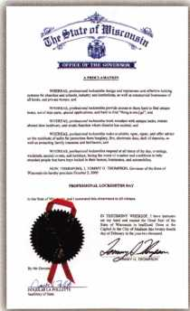

Keynotes



* Circulate a petition signed by customers on the need for such a day. Submit to your legislator.
* Check in with your state repre­sentatives' and senators' office from time to time and see how the process is coming. Usually a staff person is put in charge of proclamations.
* When the proclamation is passed by the legislature, make sure you arrange to be there for the Governor's signing of it.

Most states require that you go to the state capital to pick up the proclamation anyway, so make sure you get a photo op out of it!

* NOTE: every state is different, so check with your own state representative or senator first on the proper procedure.
* Make as many copies of the proclamation as you can, and send it to every newspaper in the state asking that they let their readers know that it is "Professional Locksmiths Day."

Many chapter and association mem­bers offer special services that day including speaking at schools or neighborhood associations to give a seminar on how to secure your home and business, free key cutting that day, free home security screening - the possibilities are endless!

But the bottom line is: it helps pro­mote the industry and you by edu­cating the public and legislators on what you REALLY do.

Special thanks to ALOA members Lee Griggs, John Dorsey, CML and Bill Smith, RL for their help with this article.

MasterLink Security Products

ROGER ALEXANDER-TUTTLE

“...understanding the needs of locksmiths...”

Mortise/Rim/Knob Cylinders • Storefront Door Hardware  
Cabinet Locks • Chain • Key Blanks • Padlocks • Pins ...and more

Local: (954) 730.9669 • Toll Free: (877) 347.9669

Fax: (954) 486.0575

e-mail: [masterlink@mindspring.com](mailto:masterlink@mindspring.com)

3S63 NW 19th Street, Lauderdale Lakes, FL 33311

It's True

Marray has developed the first  
screwless door loop.

Standard 18”  
length. Can be  
ordered in cus-  
tom lengths

Plastic base stops  
shorts and pro-  
tects wires

Screwless base and cap means you drill two 1/2 inch diameter holes, pop the base into the hole, wire your system and snap on your covers. Simple as 1, 2, 3.

**Here’s the best part We are giving away a**

FREE SAMPLE TO THE FIRST **10O** CALLERS WHO MEN-  
TION THIS ADD. **A $14.40** WHOLESALE PRICE VALUE.

CALL TODAY, IT’S FREE!!

1-800-500-1449

Marray *enterprises, inc.*

At **Marray,** we’re not just modifiers, we’re Master Hardware Modifiers™  
**1128 Walsh Ave., Santa Clara, CA 95050. [www.marray.com](http://www.marray.com)**

Aluminum ma­terial means true anodizing.

No off color powder coat­ing or painting

HplRH

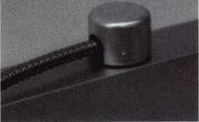

Keynotes



*sswml*

EMPLOYMENT

WANTED;EXPERIENCED TECHNICIANS

Lock into your future now! If you are an experienced, intelligent technician, and desire a secure future, come join our team. We are a full service commercial / resi­dential security service (locks,keys,safes,access control,cctv,all door related hardware,alarm systems) We offer: large sign on bonus, top wages, company vehicle, 401k, paid vacation and holidays, health benefits, new uniforms, cross training, and JOB SATISFACTION. We are looking for the best tech's who are ready to be treat­ed and compensated as professionals. Contact: Bass Security Services, INC. ph#216-755-1 200 ext# 128 • fax#216-755-1 220 • toll free #800-523-1422 • e-mail [rmesnick@bass-security.com](mailto:rmesnick@bass-security.com)

SERVICE TECH WANTED

Long Beach, CA. area experienced in all phasis required. Camera Technician a big plus! Call Jack at (562) 597-8888

SAFEMASTERS

A nationwide industry leader, has several opportunities available for experienced technicians knowledgeable in any of the following specialties: Access Control, CCTV, Safes, or General Locksmithing. As an innovative Family Friendly employer our employees enjoy flexible schedul­ing, 401 (k) and company match, health, dental and vision insurance, Long and Short Term disability insur­ance, company vehicles, opportunities for advancement, company paid training programs, technical skills updates, new product training, trade schools and college courses, generous leave programs, etc. We are commit­ted to our associates and their families as we stand side by side in sharing the rewards of hard work and cus­

tomer friendly professional service, with all our associ­ates. Our team effort makes Safemasters an enjoyable career experience which provides many opportunities to advance your career, your skills, your personal life. We hold our associates in the highest esteem because we know they are the best in the industry and take pride in a job well done. It is through this dedication and loyalty that we continue to grow and expand offering all associ­ates the stability of a company with over 60 years of experience, a committed team of support personnel to assist you in doing what you do best and a realistic approach to balancing your work and home life. We have locations in Maryland, Virginia, Wilmington (DE), Philadelphia, Pittsburgh, Boston, New Jersey, Indianapolis, and Chicago. Stop by one of our offices and talk to the manager about your needs and how we can fill them or mail to our Headquarters at:

Safemasters, 2700 Garfield Avenue, Suite 200, Silver Spring, MD 20910, to the attention of Human Resources or email us at [hr@safemasters.com](mailto:hr@safemasters.com) .

WANTED SALES SUPERSTAR

Here We Grow Again! Bass Security Services, Inc. is looking for the best of the best. If you are an experi­enced, motivated, and no-nonsense sales professional with an extensive background in the security industry, we want YOU! All candidates must have a minimum of 7 years in the locksmith / security field, with a background in sales and customer service. We offer: Top wages with excellent incentives, 401k, paid vacation and holidays, health benefits, and continued industry education. Re­location assistance may be provided.

Contact: Bass Security Services, Inc. • Ph#216-755- 1200 Ext# 128 Fax#216-755-1 220 • e-mail/ [rmes- nick@bass-security.com](mailto:rmes-nick@bass-security.com)



Keynotes

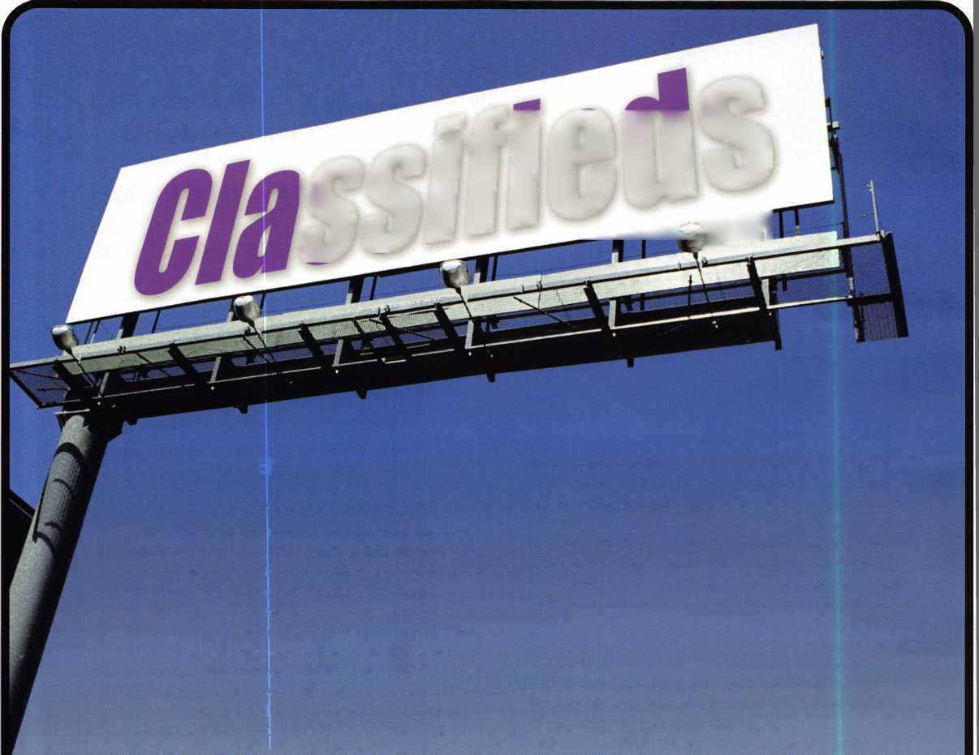

EXPERIENCED LOCKSMITH WANTED

Las Vegas-based company that deals with all phases of surveillance, access control and locksmithing is looking for a highly qualified and motivated individual to perform locksmith duties. Vegas Valley Locking Systems Inc. has an established customer base and is expanding. Qualified individuals will have extensive experience in locksmithing, safes, and door hardware. Electronic hardware expe­rience is a plus. Great benefits. Salary DOE. Please call and/or fax resume to: James Rochester • 6207 Industrial Road • Las Vegas,

NV 89118 • 702/614-3939 • 702/614-8052 (fax)

LOCKSMITH WANTED

Looking for serious, dedicated professionals to make at least $50K/year. Come to the cool Gulf shores of Houston, TX. Home for all the great fishing, sun and fun you can stand. Home of low pay­roll taxes, low cost living and the good life. Great job opportunity for the right person. Offering fantastic pay, paid vacation and holi­days, great bonus program and growth opportunity in CCTV and alarms. Professional people with tools and vehicles.

Call 281/830-9441 or fax 71 3/266-4350.

EXPERIENCED LOCKSMITH

Growing, established 22-year company is seeking lead locksmiths. Experience required in commercial locksmithing, including safe work and electronic access,CCTV, panic hardware, master key sys­tems. Work in and around the nation's Capitol. Excellent opportuni­ty for individual dedicated to the trade and to customer service. Company provides vehicle, tools and uniforms. Salary commensu­rate with experience. Paid holidays, vacations, health insurance and 401 (k). Please fax resume to 301/424-3080 or call toll free 888/424-LOCK (5625).

LOCKSMITH FOR HIRE

Northern New Jersey Locksmith looking for employment with quality company. Experience with most hardware including Medeco.

Jim Nasta at 973/815-1627.

BUSINESS FOR SALE

Established locksmith and security business for sale. Are you looking for a great business opportunity, sinchine, clean air and a great community for raising a family? We've got it! Building, businesses and rental property are all included. Business is located in south central Colorado in a growing community. Call PORTER REALTY for more information! 719/589-5899.

BUSINESS FOR SALE

Mobile locksmith business for sale, retiring, established 15 years. Western Maryland year-round resort area. Lake and ski resort near­by. Fast-growing area. Only full-time locksmith in area.

Call 301/387-6026.

FOR SALE

Established locksmith business for sale in Pembroke Pine, FL. Same location since 1972. The store comes with equipment, two vans and residential and commercial accounts. Grosses over $100K per year. Serious inquiries only. Please contact Peter at 954/962-4535.

BUSINESS OPPORTUNITY

Associated Locksmith Network, Corp. is looking to subcontract lock­smith companies around the nation and in the Caribbean. If interest­ed, request an application now at New Accounts (AL0100) at P.O. Box 771296, Miami, FL 33177-9998

WANTED TO BUY/SELL

FOR SALE

100-ACE Realtor, over the door lock boxes. All keyed alike - only $3 each. Call, Key Hole at 806/352-2157. Weekdays only, 8:30 a.m. to 5:30 p.m.

FOR SALE

LeFebure Safe Deposit Locks 7700 and 7750, nickel and brass-plat­ed. Keyways are flat/flat, with double small noses. $38, each with renter keys. Some other safe deposit locks are also available:

Mosler, S&G, llco Unican, HHM. Call toll free 888/245-6870.

WANTED: AUTO KEY BLANKS

Wanted - old auto key blanks, Hurd, Briggs & Stratton, Yale. Will pay $1 each. Douglas Vogel, 4779 Meadowlark Lane, Dexter, Ml, 48130.

FOR SALE

Buy things you need from my inventory and save 50 percent off wholesale. Call the Post Key Co toll free at 888/949-7089.

Classified Advertising Policy

Classified advertising space is provided free of charge to ALOA members, and for a fee of $.60 per word, $15 minimum for non-members. Classified ads may be used to  
advertise used merchandise and overstocked items for sale, "wanted to buy" items, business opportunities, employment opportunities/positions wanted and the like. Mem-  
bers or non-members wishing to advertise services or new merchandise for sale may purchase a "Commercial Classified Ad," for a fee of $1.30 per word, with a mini-  
mum of $40. Each ad will run for two issues. For blind boxes there is a $5 charge to members and non-members. All ads must be submitted in writing to the ALOA office  
by the fifteenth of the month, two months prior to issue date. Send to Keynotes Classifieds, 3003 Live Oak St., Dallas TX 75204-6186. ALOA reserves the right to refuse  
any classified advertisement that it deems inappropriate according to the stated purpose of the classified advertising section.

Keynotes



MANUFACTURERS

A & B Safe Corp.

(800) 253-1267 FAX (856) 863-1208

Abloy Door Security

(514) 335-9500 FAX (514) 335-0430

Adams Rite Manufacturing Co.

(909) 632-2300 FAX (562) 699-5094

Adesco Safe Manufacturing Co.

web: [www.adesco.com](http://www.adesco.com) (800) 821-6803 FAX (562) 408-6427

Adrian Steel Company

(800) 677-2726 FAX (517) 265-5834

Alarm Lock Systems, Inc.

(800) ALA-LOCK FAX (516) 789-3383

American Lock Co.

(708) 534-2000 FAX (708) 534-0531

American Security Products (AMSEC)

(800) 423-1881 FAX (909)685-9685

Baldwin Hardware Corp.

(610) 736-4012 FAX (610) 796-4493

Buddy Products

(800) 886-8688 FAX (312) 733-8536

BWD Automotive

(334) 874-9001 FAX (334) 874-6011

COMPX Security Products

(864) 297-6655 FAX (864) 297-9987

Curtis Industries

(800) 555-5397

Cygnus Business Media, Inc.

(770) 886-0800 FAX (770) 889-7703

DETEX Corporation

(800) 729-3839 FAX (830) 620-6711

DORMA Architectural Hardware

1. 336-3881 FAX (717) 336-3500

Don-Jo Manufacturing, Inc.

(978) 422-3213 FAX (978) 422-3467

Doyle Security Products

(800) 333-6953 FAX (612)521-0166

DSC Group of Companies

(905) 760-3000 ext. 2200 FAX (905) 760-3040

Door Controls International

(800) 742-3634 FAX (800) 742-0410

ESP Lock Products, Inc.

(978) 537-6121 FAX (978) 534-9109

Ewert Wholesale Hardware

(800) 451-0200 FAX (708) 597-0881

Fairway Supply, Inc.

(214) 350-0021 (214) 352-4299

H.L. Flake Co.

(800) 231-4105

HES, Inc.

(623) 582-4626 FAX (623) 582-4641

Hardware Agencies, Ltd.

(416) 462-1921

Hongtai Lock Co Ltd.

(137) 238-1414 FAX (208) 793-3856

llco Unican

(252) 446-3321 FAX (252) 446-4702

Intellikey

(800) 226-0703 FAX (407) 724-0811

Jet Hardware Mfg. Co

1. 257-9600 FAX (71 8) 257-0973

KABA High Security Locks

(860) 621-3601 FAX (860) 621-9727

KEY-BAK; Div. of W. Coast Chain Mfg.

(909) 923-7800 FAX (909) 923-0024

Knaack Manufacturing Co.

(800) 456-7865 FAX (815) 459-9097

LAB Security

(800) 243-8242 FAX (203) 583-7838

LCN Closers (Division of Ingersol)

(815) 875-3311 FAX (815) 875-3222

La Gard, Inc.

(310) 325-5670 FAX (310) 325-5615

Lucky Line Products

(619) 549-6699 FAX (619) 549-0949

M.A.G. Engineering & Mfg. Inc.

(714) 891-5100 FAX (714) 892-6845

MARKS USA

(516) 225-5400 FAX (516) 225-6136

MARRAY ENTERPRISES

(408) 970-0213 FAX (408) 970-8767

Master Lock Company

(414) 444-2800 FAX (414) 449-31 14

Medeco Security Locks

(540) 380-5000 FAX (540) 380-5010

Meilink Safe Company

(800) 634-5465 FAX (800) 896-6606

MMD Inc.

(602) 453-3169 FAX (602) 438-1690

Massglass & Door Service

(888) 742-8837 FAX (818) 991-5742

Monaco Lock Co.

(800) 526-6094 FAX (800) 845-5625

ROFU International Corp.

(800) 255-7638 FAX (253) 922-1728

Rutherford Controls Int'l. Corp.

(757) 427-1230 FAX (757) 427-9549

SARGENT Manufacturing Co.

(800) 727-5477 FAX (888) 863-5054

STRATTEC Security Corp.

(414) 247-3333 FAX (414) 247-3329

Sargent & Greenleaf, Inc.

(606) 885-941 1 FAX (606) 887-2057

Schlage Lock Co.

(800) 847-1864 FAX (800) 452-0663

Schwab Corporation

(765) 447-9470 FAX (765) 447-8278

Securitron Magnalock Corp.

(800) 624-5625 FAX (702) 355-5636

Security Door Controls

(805) 494-0622 FAX (800) 959-4732

Security Solutions

(405) 376-1600 FAX (405) 376-6870

Sentry Group

(716) 381-4900 FAX (716) 381-8559

Somerset Security Products

(800) 881-5206 FAX (800) 206-9949

Sully Tools Inc.

(703) 689-3416 FAX (703) 787-0869

Taymor Industries, Inc.

(800) 388-9887 FAX (800) 288-8133

The National Locksmith

(630) 837-2044 FAX (630) 837-1210

MCS Communication Systems

(865) 428-3611 FAX (865) 453-4136

Sun-IL Gum Go

(823) 194-59300 FAX (823) 194-59400

Keynotes

Trine Products Corporation

(718) 829-4796 FAX (718) 792-9127

Videx, Inc.

(541) 758-0521 FAX (541) 752-5285

W-Lok Corporation

(616) 355-4015 FAX (616) 355-4295

Yale Security Inc.

(800) 438-1951 FAX (800) 338-0965

DISTRIBUTORS

Accredited Lock Supply Co.

(800) 652-2835 FAX (201) 865-5031

Ace Lock & Security Supply Co.

(800) ACE-LOCK (800) ACE-FAX4

ADI

(516) 692-1000 FAX (516) 692-3457

Andrews Wholesale Lock Supply

(717) 272-7422 FAX (717) 274-8679

Boyle & Chase Inc.

(800) 325-2530 FAX (800) 205-3500

Clark Security Products, Inc.

(800) 854-2088 FAX (619) 974-5284

Cook's Building Specialties

(505) 883-5701 FAX (505) 883-5704

Dire's Lock & Key Co.

(303) 294-0176 FAX (303) 294-0198

Direct Security Supply, Inc.

(800) 252-5757 FAX (800) 452-8600

Doyle Security Products

(800) 333-6953 FAX (612) 521-0166

Dugmore & Duncan Inc.

(888) 384-6673 FAX (888) 329-3846

E. L. Reinhardt Co., Inc.

(800) 328-1311 FAX (612) 481-0166

Foley-Belsaw Company

(800) 821-3452 FAX (816) 483-5010

Fried Brothers, Inc.

(800) 523-2924 FAX (800) 541-3489

HS&S Wholesale Distributors

(800) 521-2202 FAX (313) 342-7580

Hans Johnsen Company

(214) 879-1550 FAX (214) 879-1530

Howard Keys

(704) 598-2291 FAX (704) 598-9110

IDN, Inc.

(817) 421-5470 FAX (817) 421-5468

Intermountain Lock & Supply Co

(800) 453-5386 FAX (801)485-7205

Jo-Van Distributors Inc.

(416) 752-7249 FAX (416) 752-3845

Lockmasters, Inc.

(800) 654-0637 FAX (859) 885-7093

Locks Company

(800) 288-0801 FAX (305) 949-3619

The Locksmith Store Inc.

(847) 364-51 1 1 FAX (847) 364-5125

M. Zion Company

(212) 349-8677 FAX (212) 964-0495

McDonald-DASH Locksmith Supply

(800) 238-7541 FAX (901) 366-0005

McManus Locksmith Supply, Inc.

(702)333-9112 FAX (704) 332-8664

MARRAY ENTERPRISES

(408) 970-0213 FAX (408) 970-8767

Securite.com

(800) 241-3930 FAX (619) 974-5269

Omaha Wholesale Hardware

(800) 238-4566

Sentry Security Fasteners

(309) 693-2800 FAX (309) 693-2872

Southern Lock and Supply Co.

(800) 237-2875 FAX: (800) 447-2299

Stone & Berg Wholesale

(800) 225-7405 FAX (800) 535-5625

Strauss Safe & Lock Company

(515) 288-9571 FAX: (515) 288-9752

Taylor Securtiy & Lock Co.

(301) 948-7670 FAX (301) 948-1029

Timemaster, Inc.

(785) 232-8705 FAX (800) 798-8463

Top Notch Distributors, Inc.

(800) 722-4210 FAX (800) 248-3620

U.S. Lock Corporation

(800) 925-50001 FAX (800) 338-5625

Webster Safe & Lock Company, Inc.

(901)332-2911 FAX (901) 332-2878

SERVICE

Allstate Insurance Company

(847) 402-8196 FAX (847) 326-7509

For more information on associate membership,

visit us online at [www.aloa.org](http://www.aloa.org)



Keynotes

back page

About the Authors

Jim Hancock, CRL, is a new ALOA ACE Instructor with many years of experi-  
ence in the security industry. He works as an Assistant Business  
Manager/Instructor at Cothran's Safe and Lock in Austin, TX.

Tom Seroogy is in the new Automotive division of  
Lockmasters. He has been the Product Manager for  
BWD Automotive (formerly known as All Lock). His  
many years of technical expertise in the automotive  
field and as a contributor to automotive locksmith  
education have created a much sought after demand  
for his popular classes. Tom has developed the new  
Automotive Locksmithing I & II classes for ALOA to  
help prepare locksmiths for the PRP automotive elec-  
tives.

Ronald "Red" Howell, CRL has been in the lock-  
smithing industry since 1959. In 1980 Red started  
his own business specializing in automotive locks..

Red began teaching in 1982 for ALOA . Red was the  
first vice chairperson for the San Diego Chapter of  
ALOA (August 1986). During the years he has held  
about every elected office for the San Diego Chapter  
of the California Locksmiths Association (CLA).

Currently , he is the San Diego Chapter President for

CLA, chairman of the San Diego Chapter of ALOA and active member of the  
San Diego Forensic Consultants Association. He also is teaching ACE ALOA  
convention classes and is currently re-writing a manual on foreign automotive  
lock repair from the 1950's to 1970'S

|  |  |
| --- | --- |
| \ Ad Index | in |
| Strattec Inside Cover | |
| Lockmasters | .20 |
| SpeedyPik | .23 |
| Turn 10 | .35 |
| JLM Wholesale | .35 |
| MasterLink | .38 |
| Marray Enterprises | .38 |
| Hickock Inc Back Cover | |
| L | J |

Merritt Perkins, RL, has been a developing member of the locksmith and eletronics industries for many years. He owns and operates Merritt L. Perkins Labs in Three Rivers, Ml.

Don Shiles, RL, has been in the physical security industry on the East Coast for many years. He owns and operates Safe Lock and Key in Severn, MD.

Greg Perry, CML, CPS, has been in the locksmith industry for 18 years. He's spend half of that time as a field technician for Security Engineering in Ridgecrest, Calif. Greg is also a past president of the Desert Counties Chapter of the California Locksmiths Association.



Keynotes

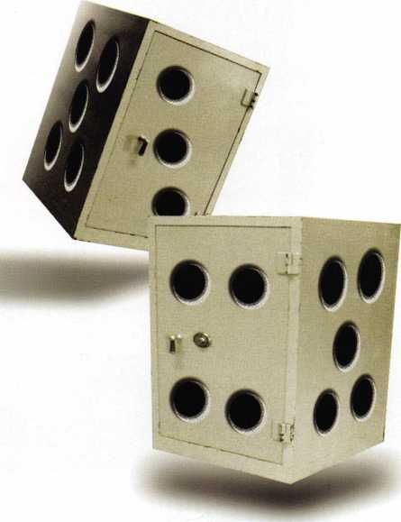

**April 8-1 3**

**John Ascuaga's Nugget Resort • Reno, Nevada**

reno, nevada



2^2

*y'd^ ax*te*

*200V£

**' Jump ahead of the competition at warp speed and see your profits soar.**

**Hickok’s New Generation STAR transports you with the factory tool for programming keys to  
Ford-Lincoln-Mercury and Mazda vehicles with passive anti theft systems (PATS).**

**Program vehicle keys through Model Year 2001 with Hickok’s NGS Model 800-8LA-$1995**

**Update your existing software-the 2001 Complete New Model Ford Software Update Model 80LA-$895**

**800/342-5080**

**HICKOK**

**INCORPORATED**

mtuiu.hickok-inc.coni

